Jenkins 2.346.3

While Running a Jenkins job if u get below error java.io.IOException: Cannot run program "nohup" (in directory "C:\ProgramData\Jenkins\.jenkins\workspace\Sonar-Jen-pipelineJob"): CreateProcess error=2, The system cannot find the file specified

To solve this issue,we need to replace ‘sh’ with bat as windows don’t support linux cmds n ‘sh’ is linux cmd n ‘bat’ is window cmd.

For eg:

stage('Build'){

steps{

sh 'mvn clean package'

}

sh will be replaced by bat

stage('Build'){

steps{

bat 'mvn clean package'

}

* Why Continuous Integration?

S/w Development is a process which includes phases like Requirement Gathering,Requirement Analysis,Designing,Coding,Testing,Deploying,Maintaining the Software.

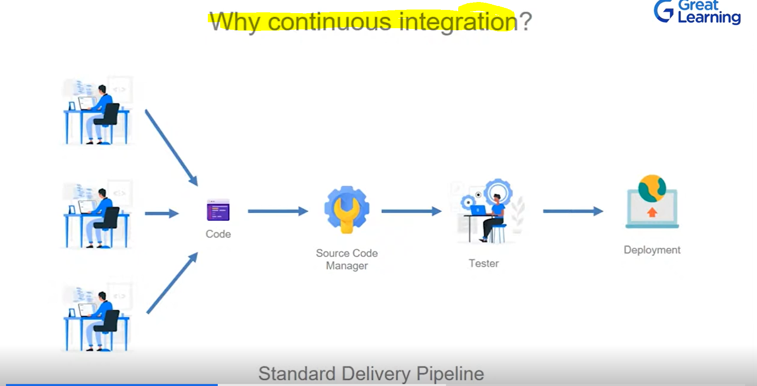

So contiuous Integration helps us to connect or automate all the 7 stages of s/w development life cycle by connecting with each other

* What is Devops?

As name implies Devops = Development + Operations .It is the bridge between dev team n operations team.It is a way of s/w development.It tries to automate the s/w development life cycle to create amazing s/w.Devops team is responsible for making the s/w development infrastructureeasy,maintainable n effective.

Devops phases includes

Continuous development: where dev team develops n pushes the code to SCM frequently.

Continuous Testing:where frequent testing happens

Continuous Integration: where continuous integrations happens.

Continuous deployment:where deployment happens frequently.

Continuous monitoring:where monitoring happens frequently.

* What is Jenkins?

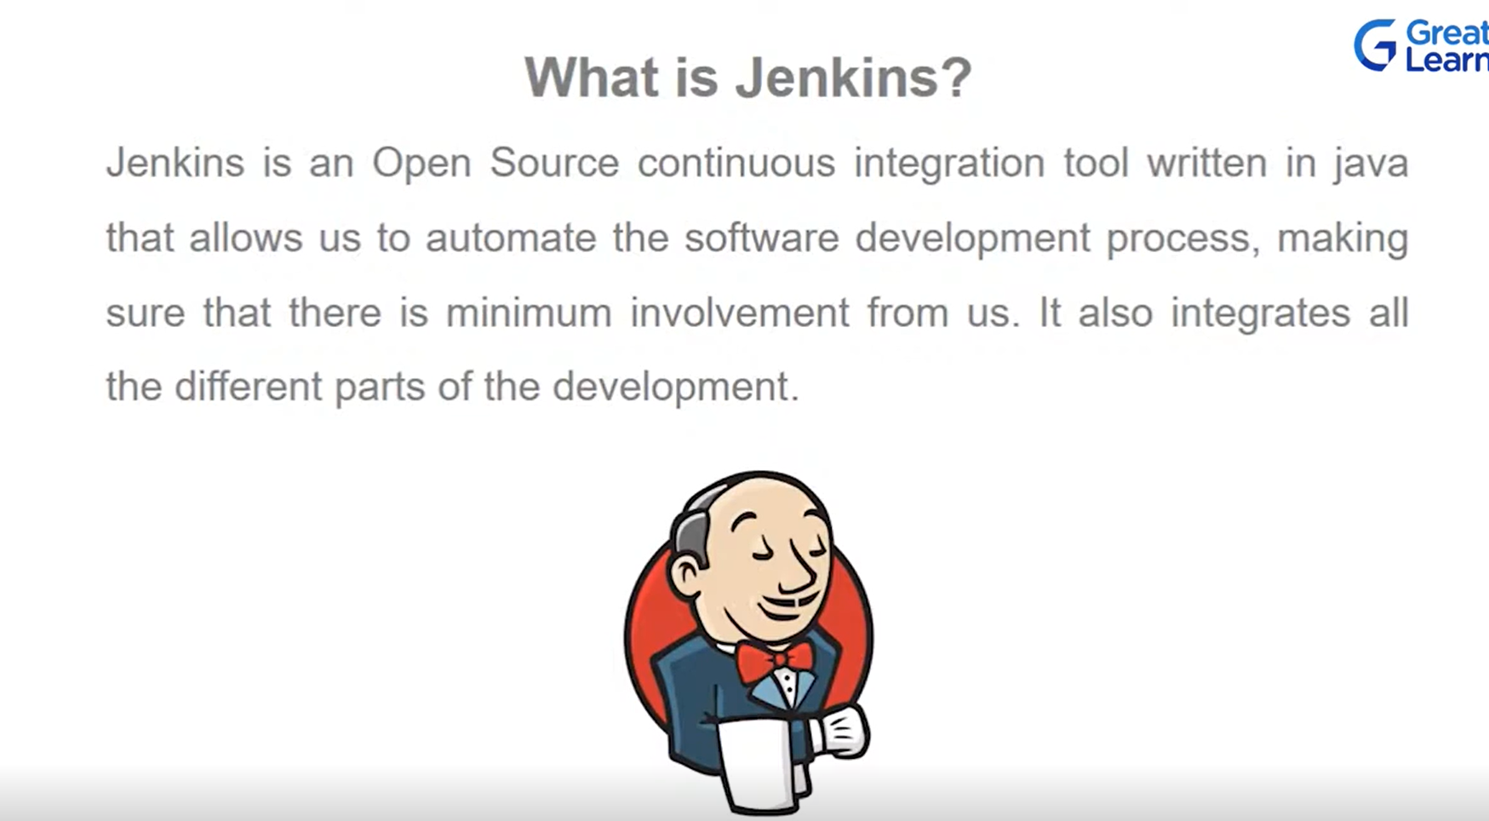

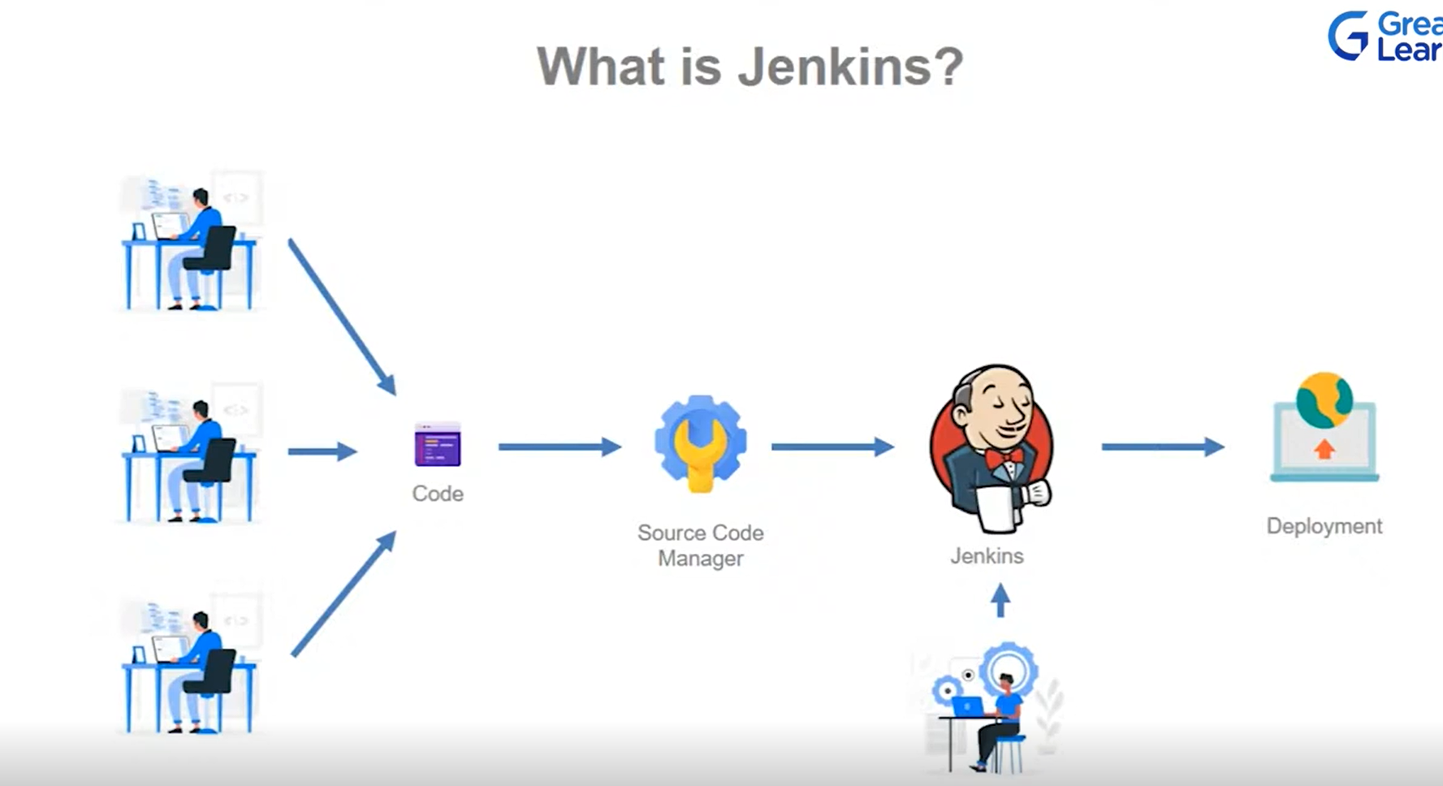

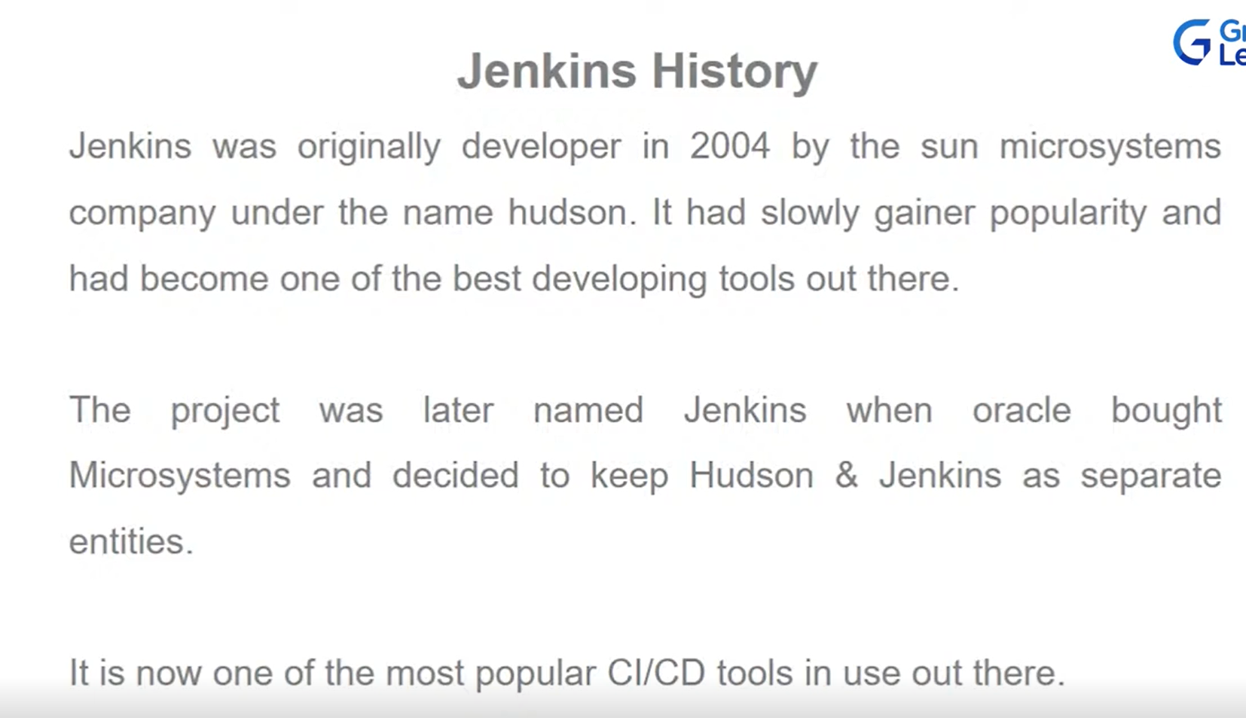

Jenkins is a framework that is used to manage all types of automation including software builds,app testing,deployments & much more.

Jenkins is:

Easy to use

Open source

Free

Extensible (Plugin & Functionality)

Community (Jenkins users around the world,Support forums)

Key Terms:

Project or Job:- A job is a collection of tasks that you, as a user want Jenkins to manage.

Build: one run of a project

Build Step: A step that Jenkins will run

Build Trigger: trigger is an event that starts a build

Plugin: is an extension to the core of Jenkins functionality

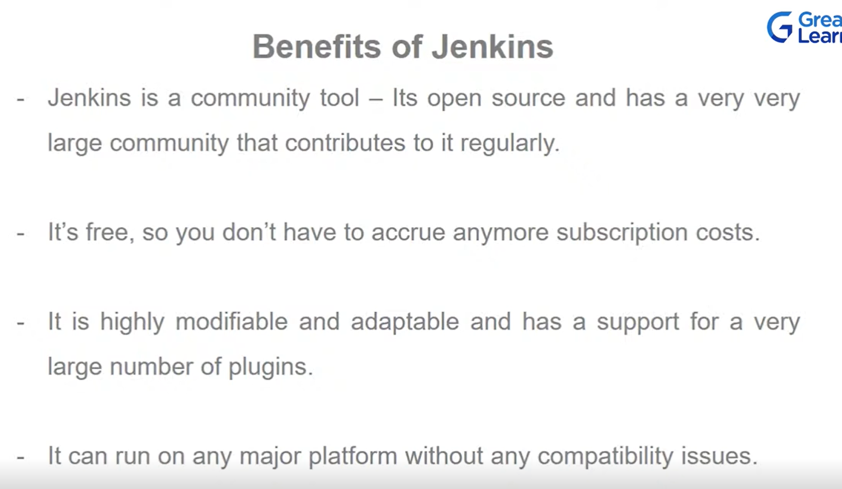

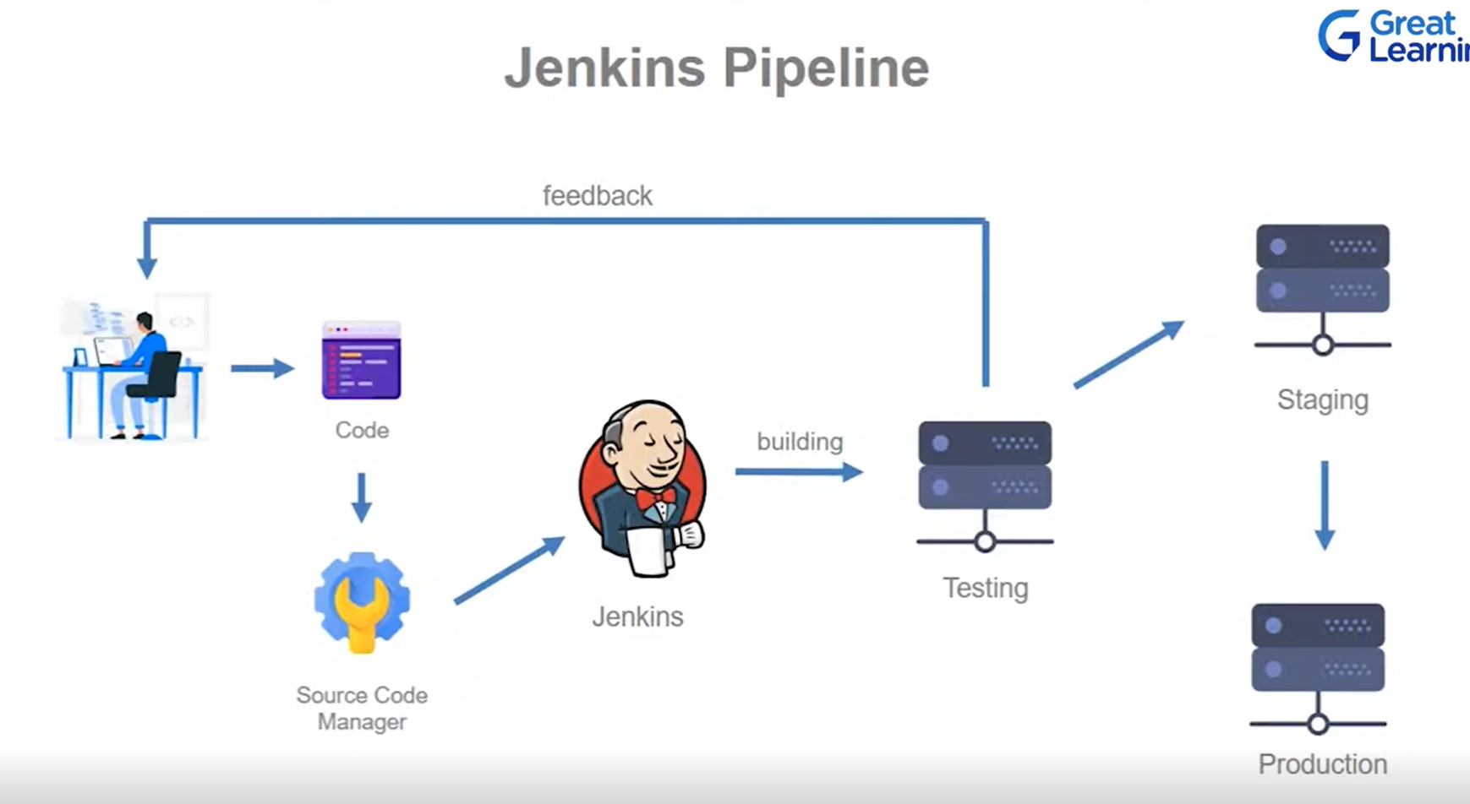

* Jenkins Architecture:

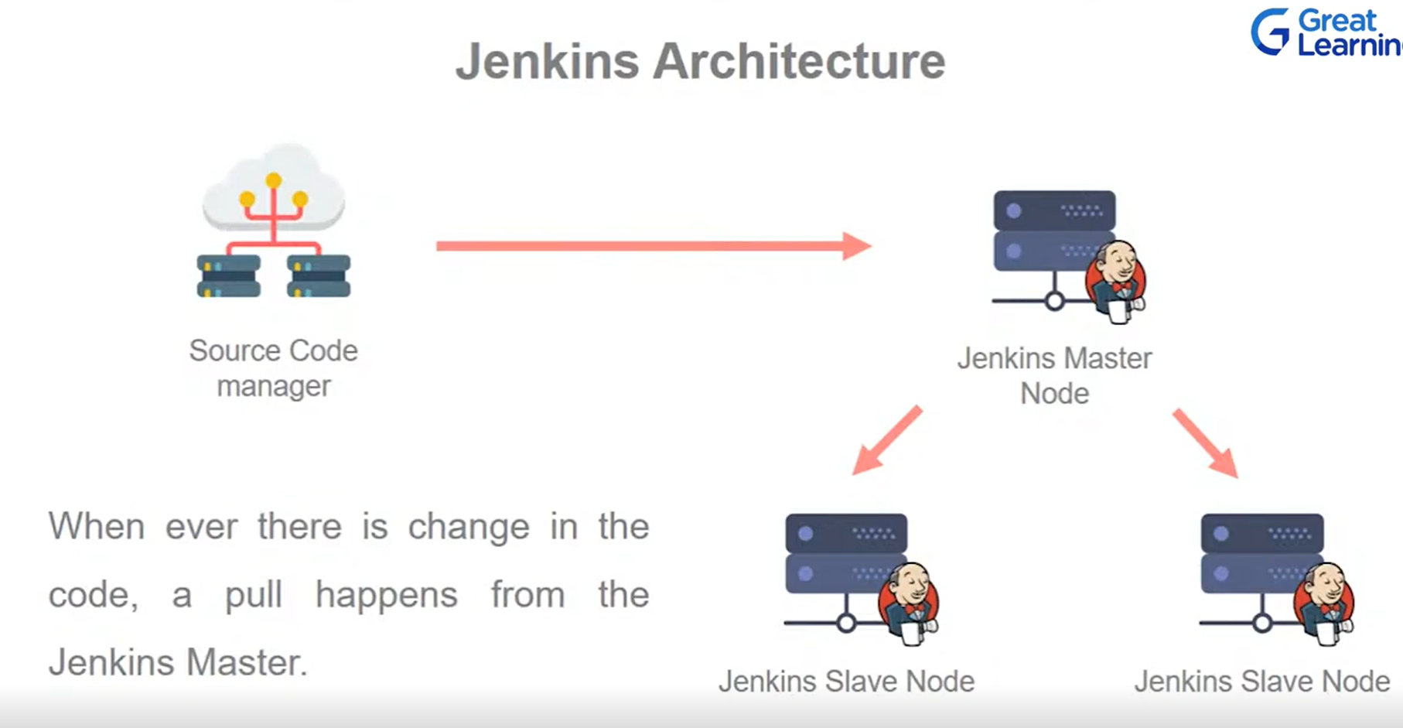

* Jenkins Installation and Setup:

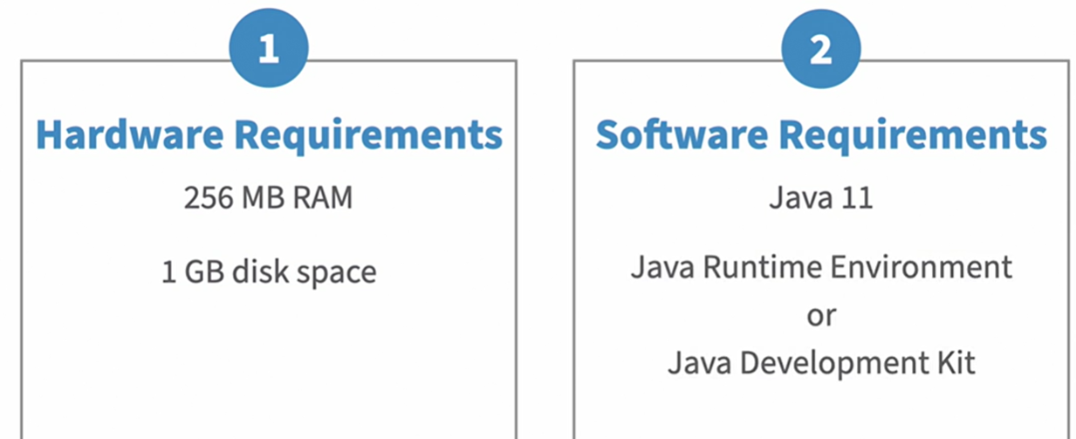

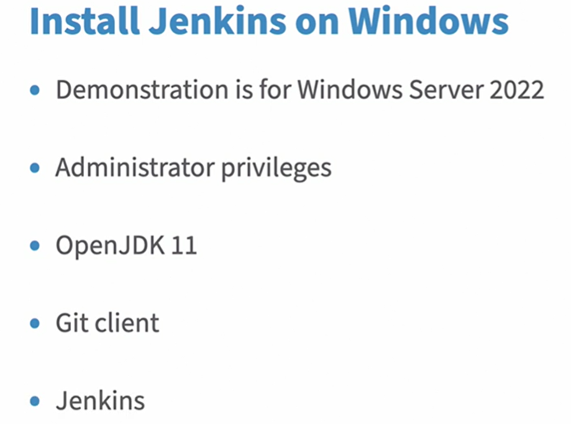

JDK can be downloaded from [OpenJDK 11 Download](https://adoptium.net/en-GB/temurin/releases/?version=11) .unzip the file n set environment path for JAVA_HOME n path variable under system variables.

Git can be downloaded from [Git Download](https://git-scm.com/downloads). N then install with default configurations.

Jenkins can be downloaded from [Jenkins Download](https://www.jenkins.io/download/). Choose wnidows n then it will download Jenkins.msi file.after download double click the msi file to open

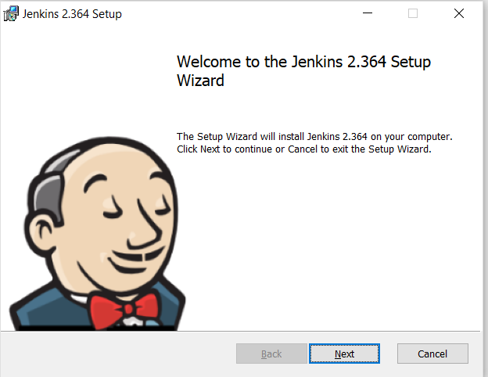

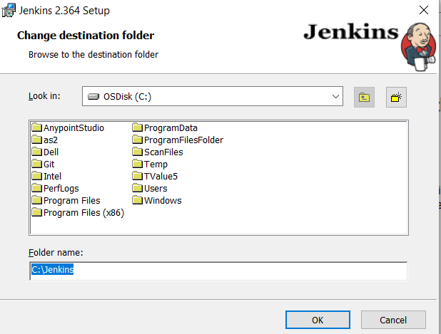

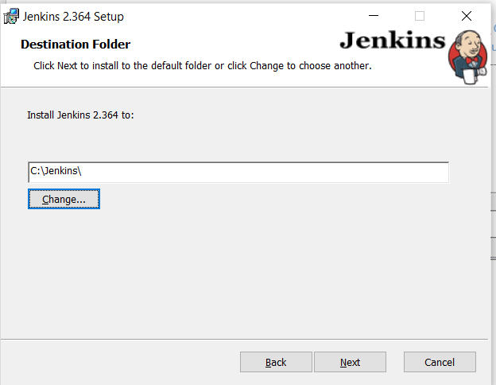

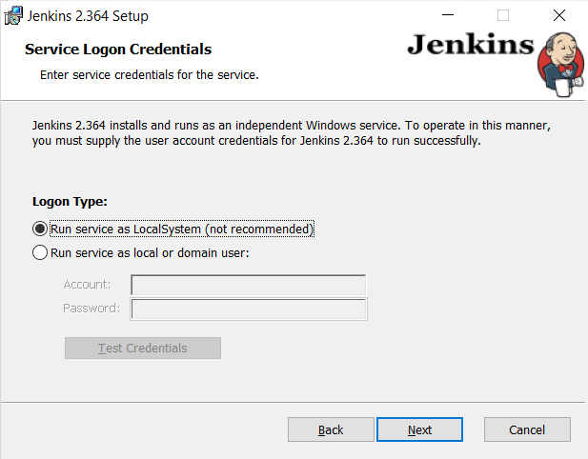

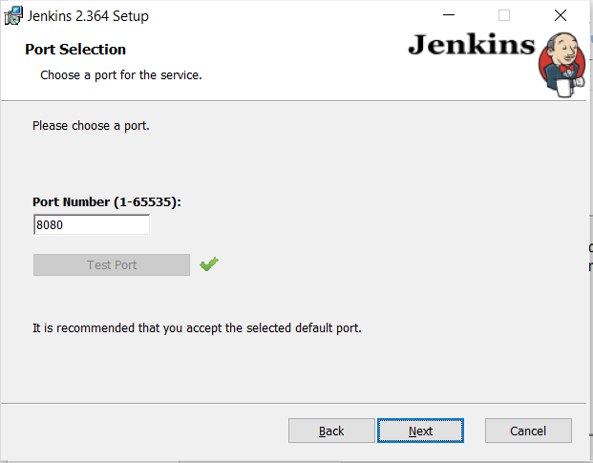

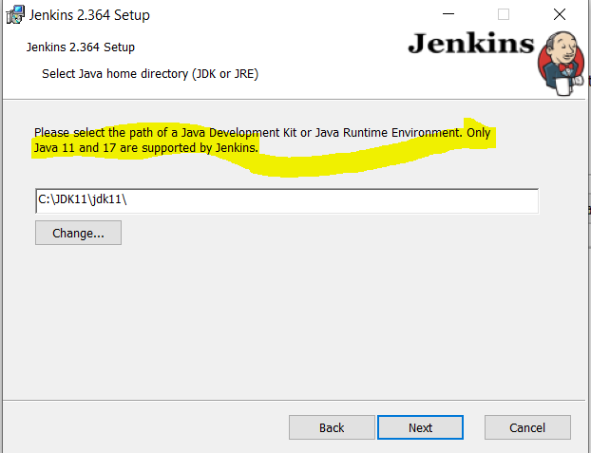

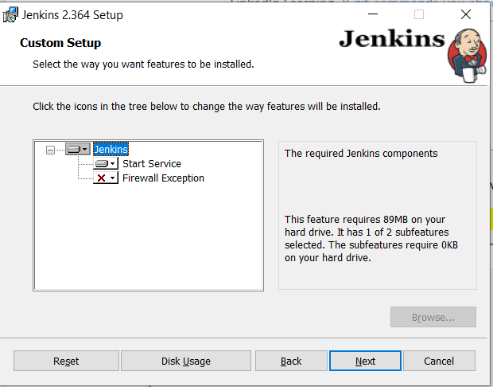

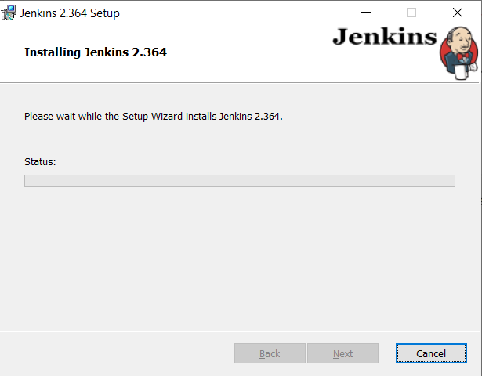

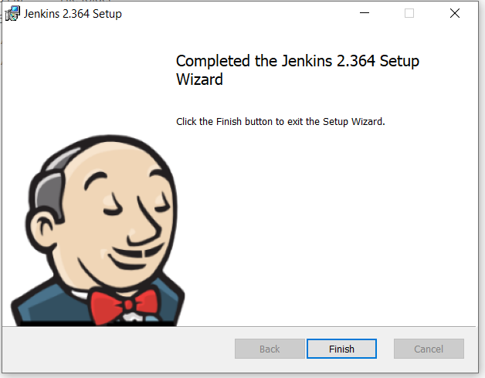

Once Jenkins gets configured it will open a browser window with below url where port will be ur configured port in this case its 8080.

<http://localhost:8080/login?from=%2F>

or u can manually open a window n paste below url: where port will be port u configured.

<http://localhost:8080>

once its done you will see below window on browser,

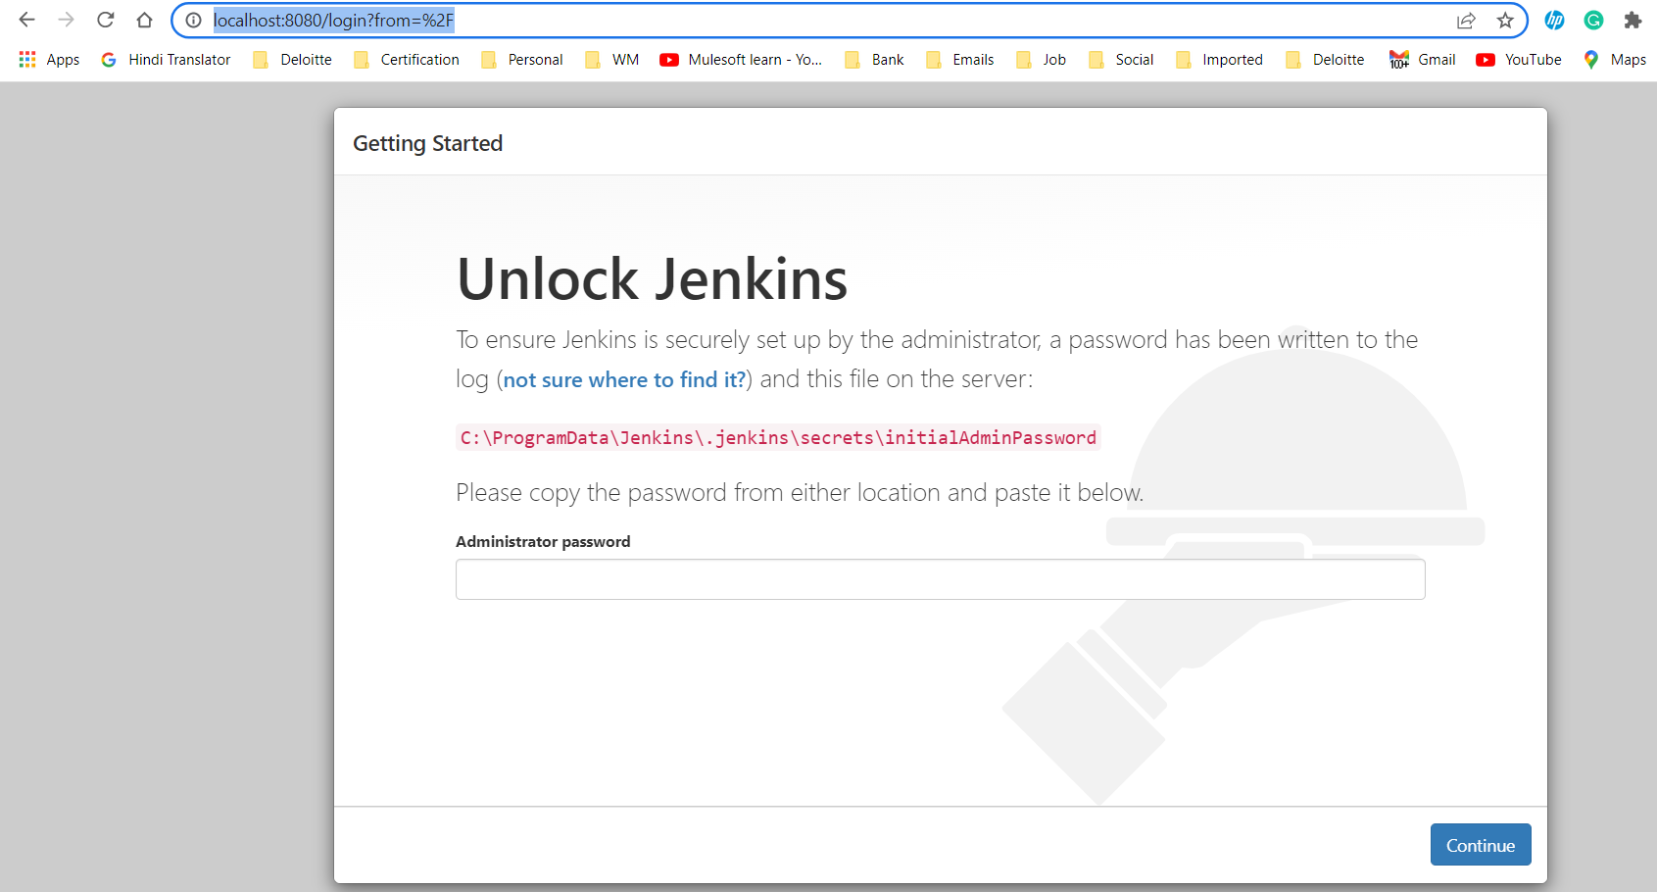

You will be asked to enter a admin password ,which u get from the mentioned path.

Copy the path n paste it in run window(ctrl+R) then u will get notepad file with password ,copy that n paste it in the Administrator Password.

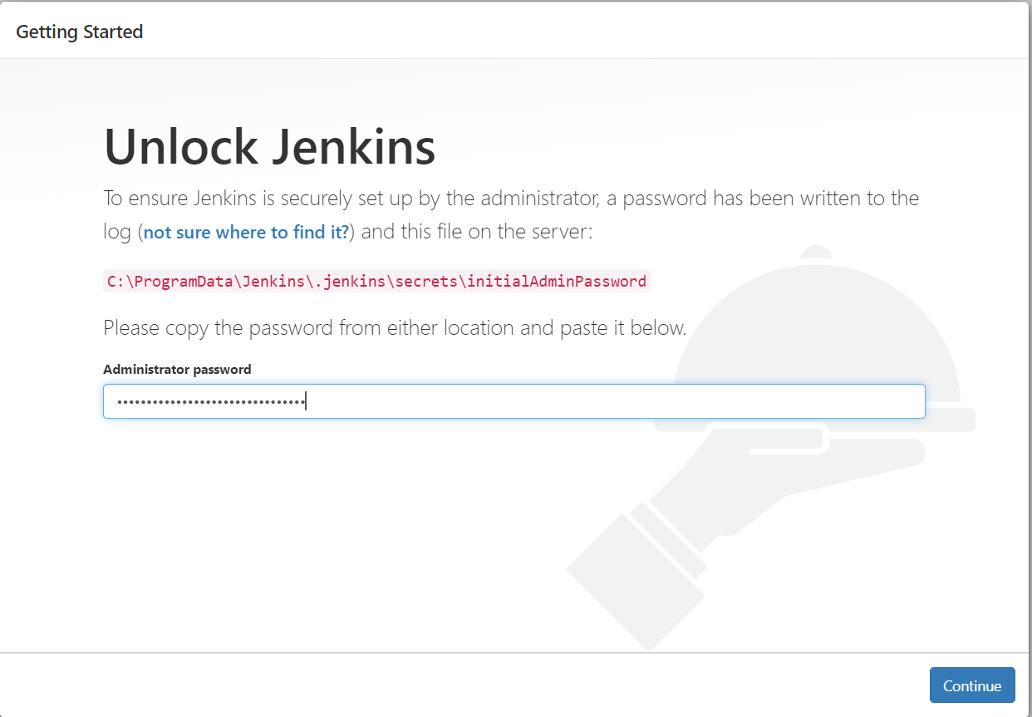

Select install suggested plugins

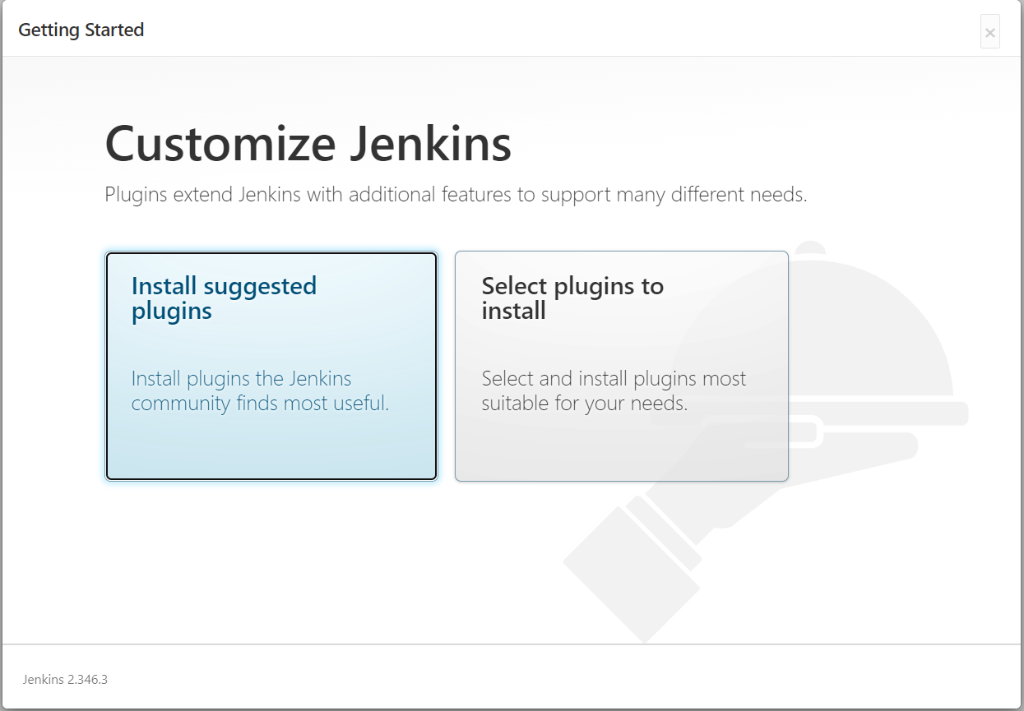

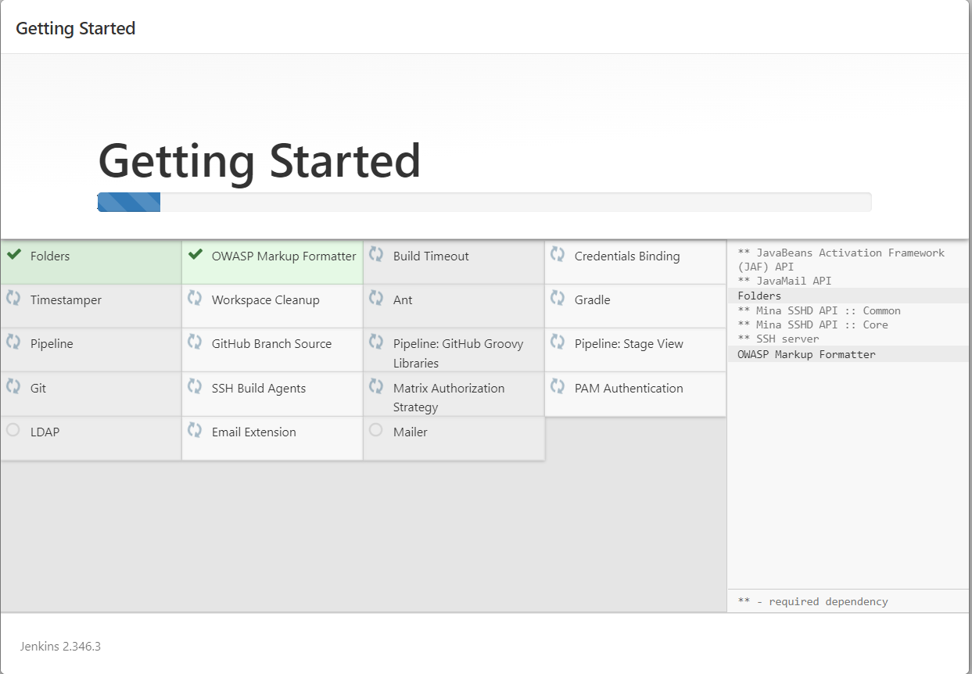

Once all gets installed,we will be presented with Create First Admin User window like below where fill the details n click on save n continue

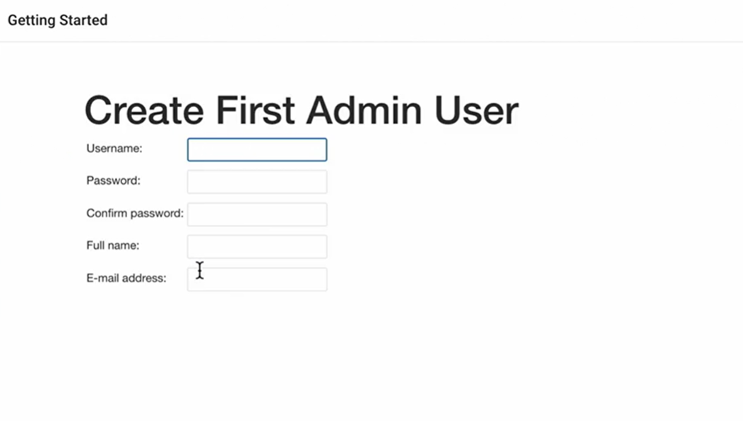

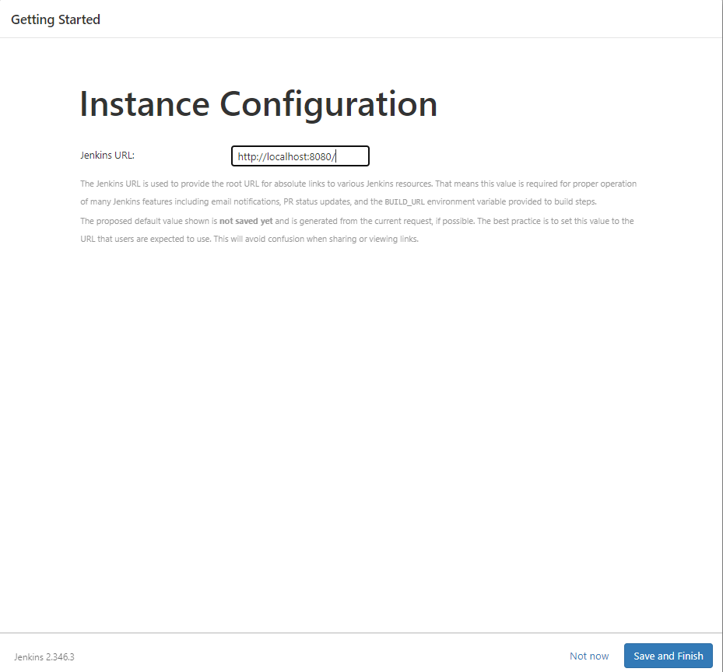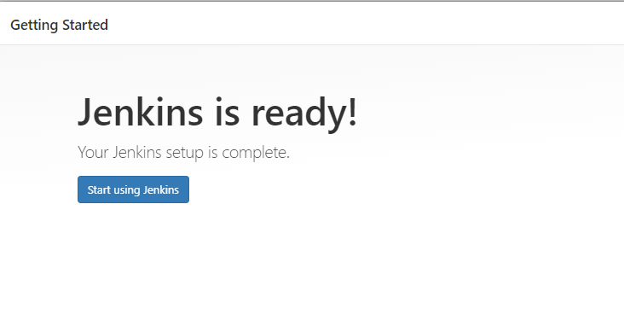

Then click on Start Using Jenkins button.

After that you will get a screen like a below:

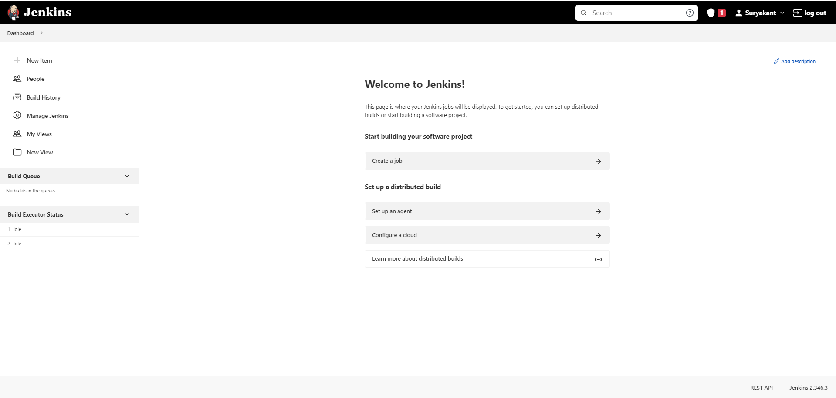

Most commonly used options are:

New Item: is the place where we create a job or resources.

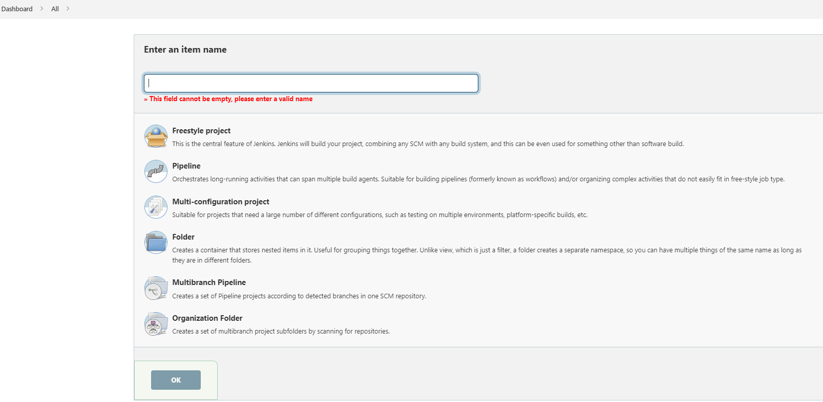

Manage Jenkins: is a place where we get options to configure our Jenkins server .

At starting we get a notification like building on a built-in-node can be security issue …..

You can dismiss this notification.

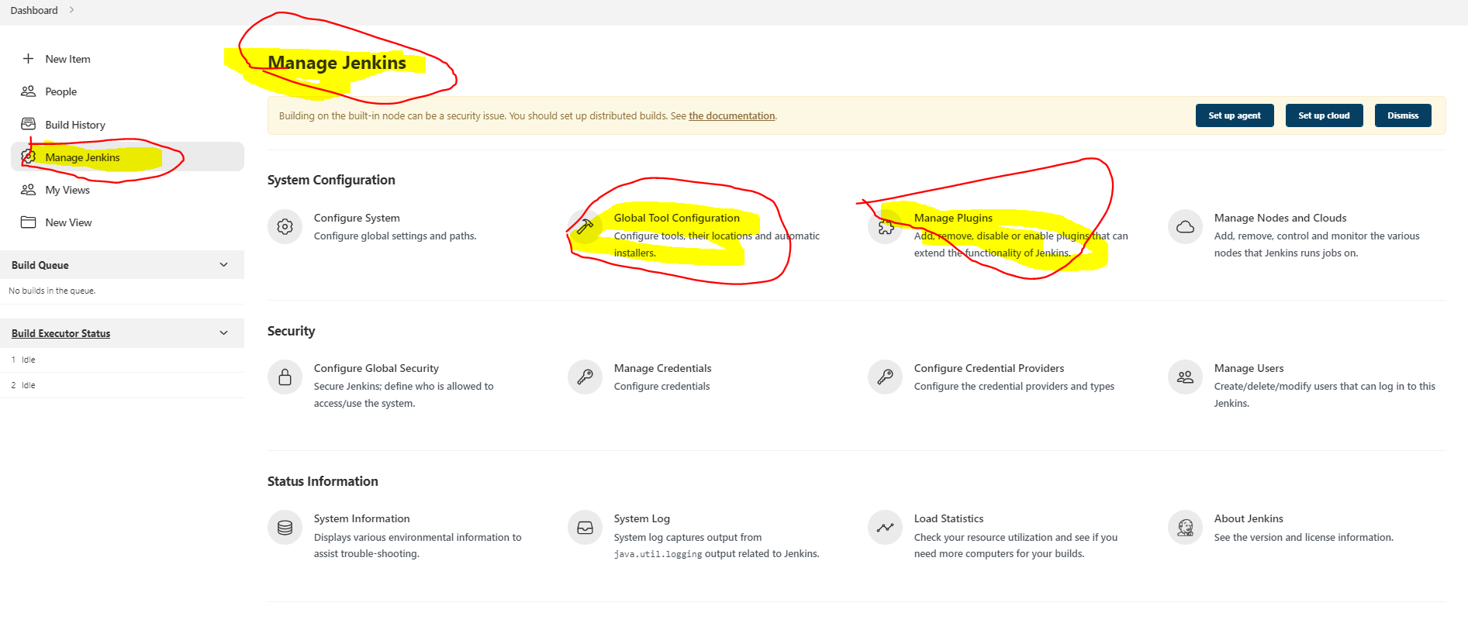

In manage Jenkins we can use

Global Tool configuration: is used to set configures for all jobs.

Manage Plugins: used to install/ update plugins.

Build Queue:is place where we can see builds list waiting to be run

Build Executor status: show Build Execution status. 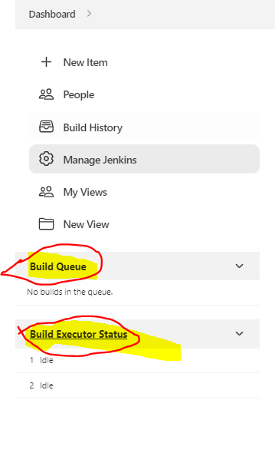

* How to install/Uninstall plugins thru Manage Jenkins->Manage Plugins tab

Click on Manage Jenkins in dashboard->select manage plugins

To install:

Go to Available tab->enter name of plugin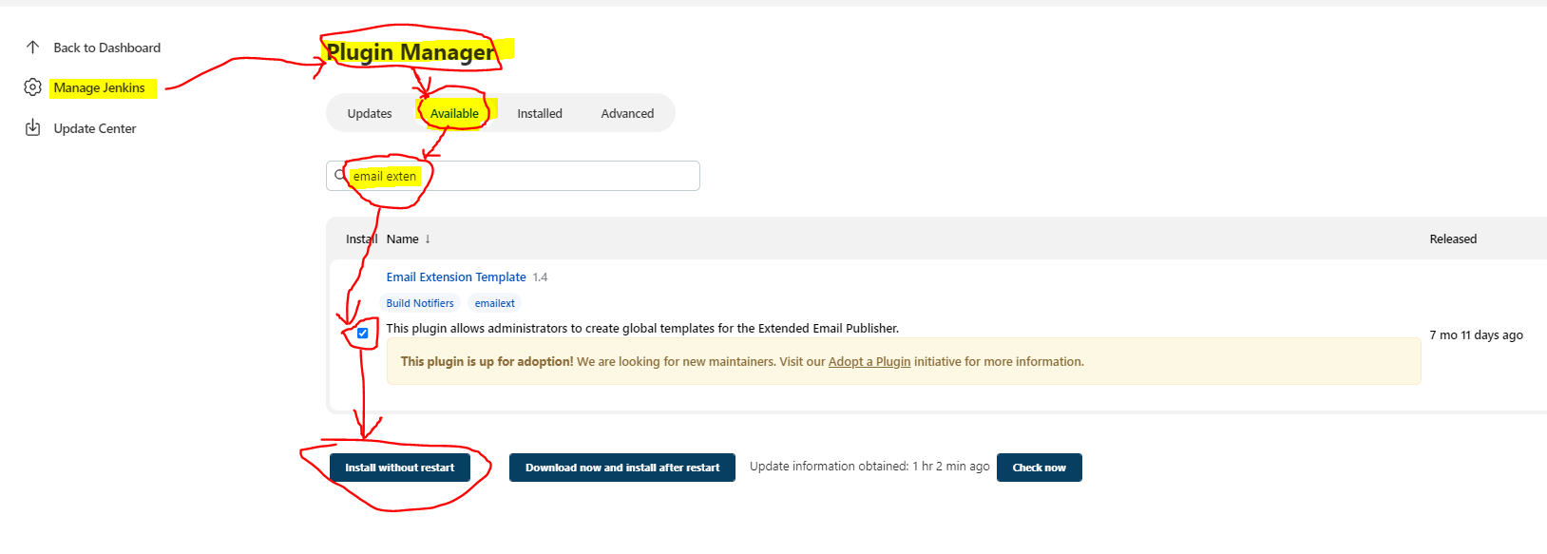

Once installed check whether that plugin is enabled or not like below,

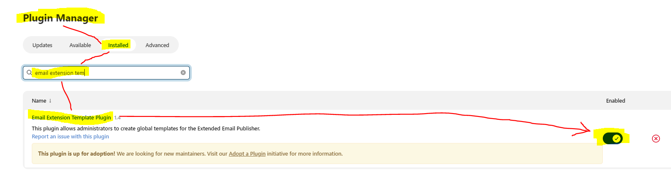

To Uninstall:

Go to Installed->search with the plugin name to uninstall->click on uninstall button.

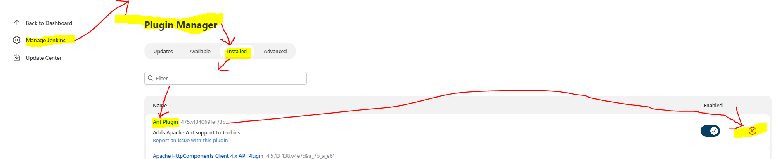

* How to use Global Tool Configurations:

Global Tool Configuration allows us to install multiple version of tool like multiple version of maven, multiple version of git, multiple version of JDK.

To use this lets go to Manage Jenkins->Global Tool Configurations->under maven click on add maven->enter configuration name(is required as we can install so many versions of maven) n click on apply

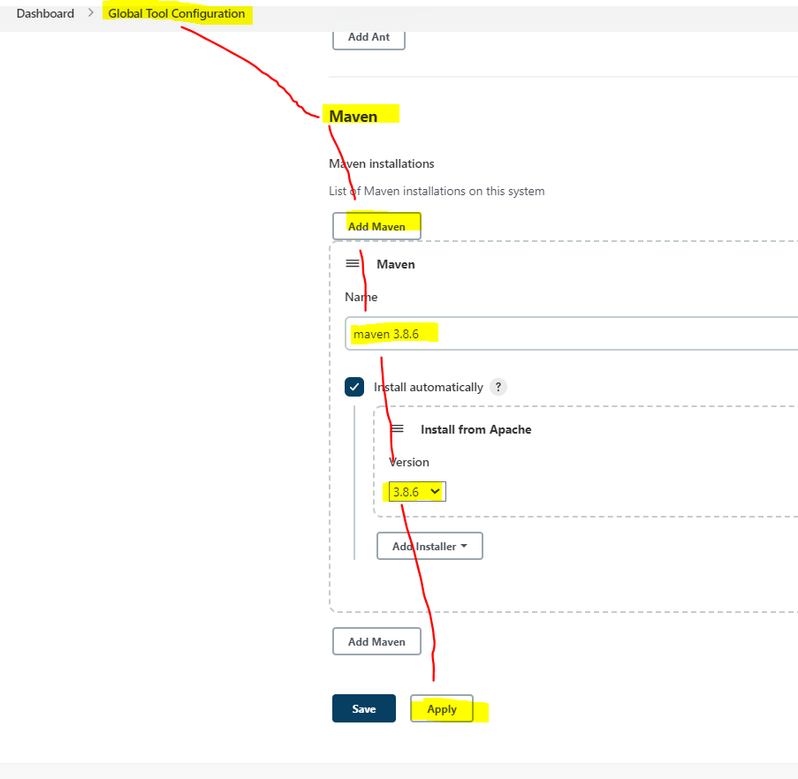

You can delete the maven version by going to the version n selecting delete

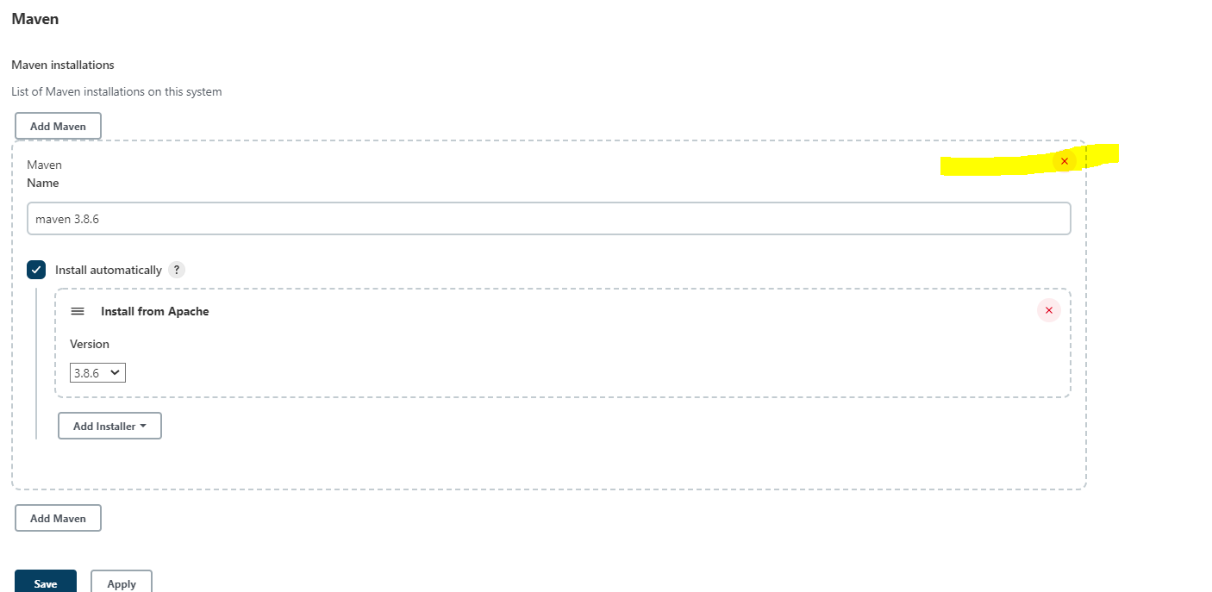

* How to create a first job in Jenkins?

Let say we want to hello world application job then go to New item->give name like hello-world ->choose freestyle project->click ok. 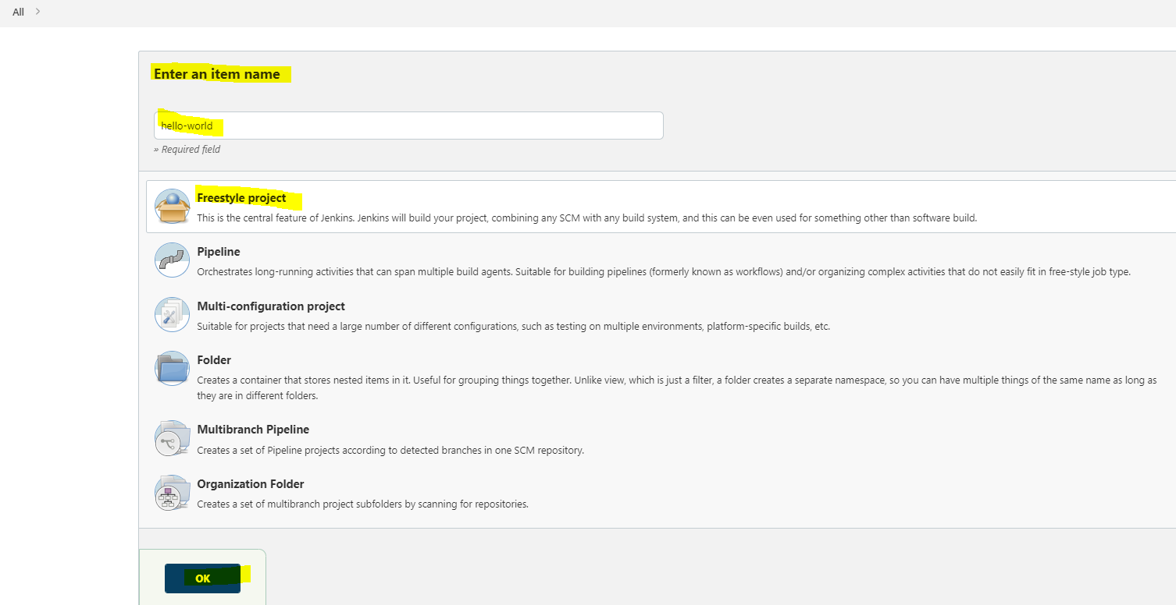

It will open another window where u can provide more info but this time we are going to build n selecting executing windows batch command as we are running on windows system. Inside the command window type echo “hello ….” N click on apply n then save.

Apply is used for saving n continuing with some other changes on the same page.so page wont be change

Save is like we are done saving all the changes in the page lets move to another page

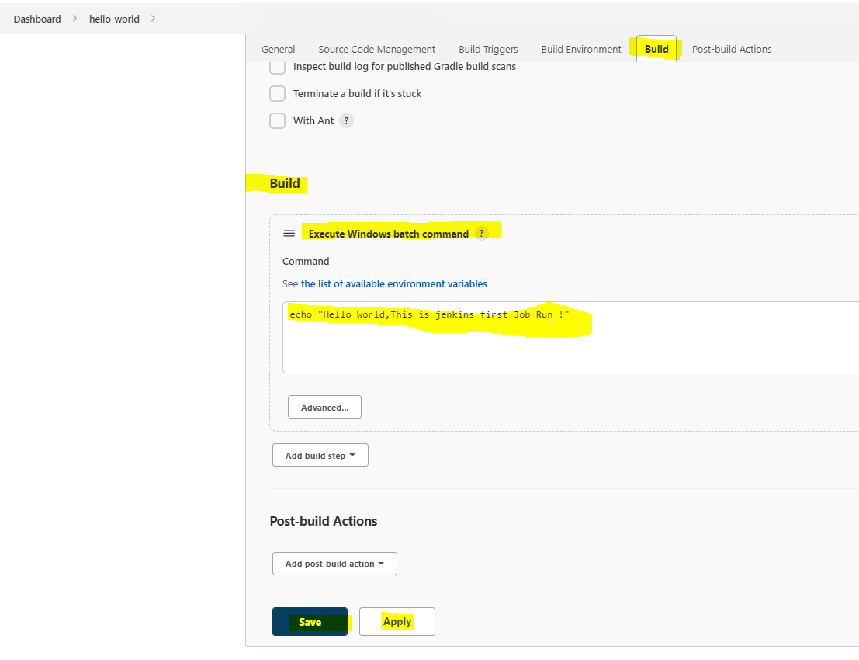

Done with click on save button you will redirected to project-dashboard there you can select Build Now button to run the job

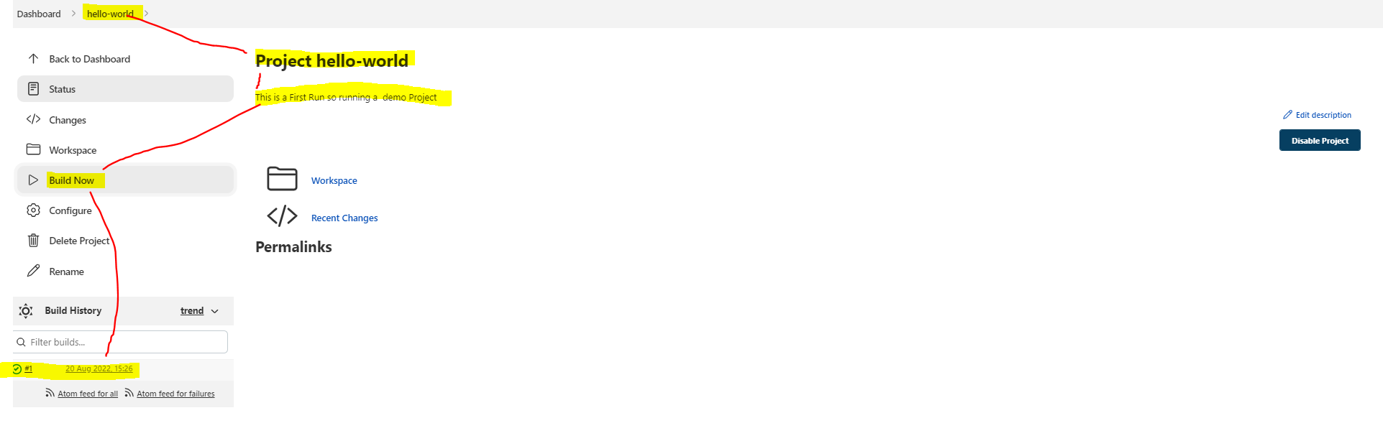

If job gets successful then gets the green icon in build history tab otherwise red icon n if job is waiting then returns grey icon.



To see the output of the build ->go to build history->click on build no which u want to see output->go to console output.

You will see “Hello World……. “ is getting printed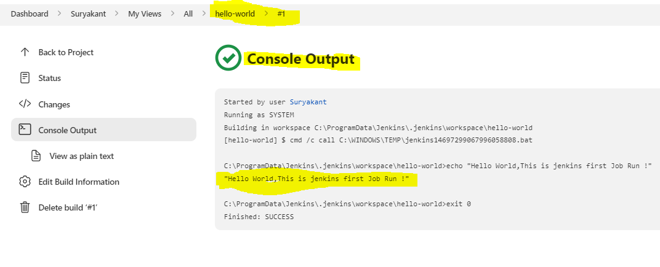

* Various Job Types:

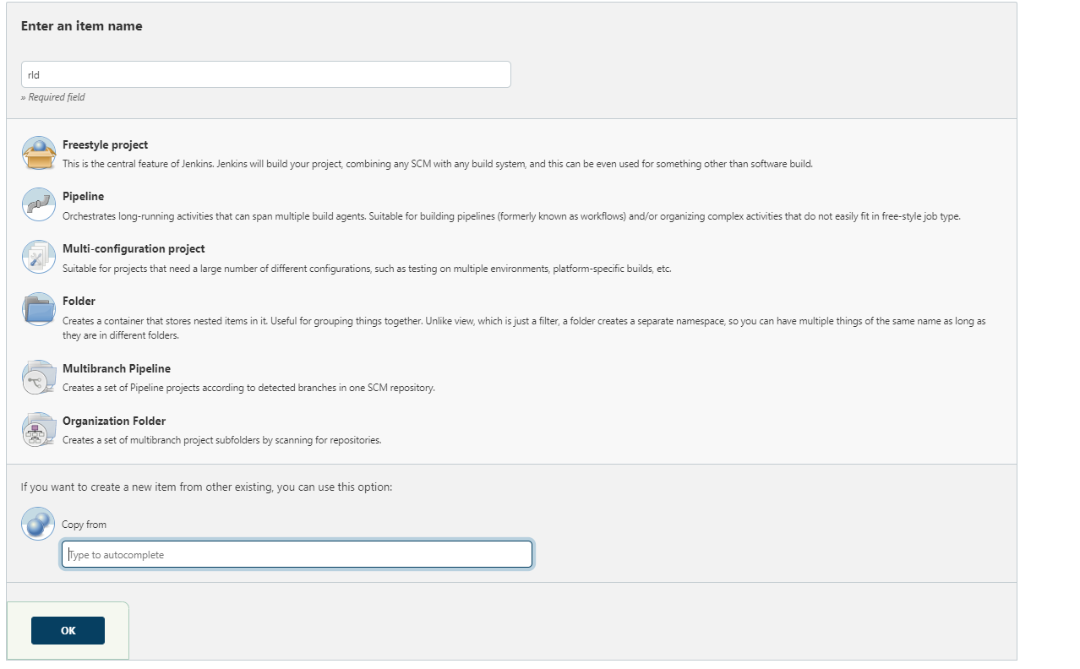

The new item button in dashboard provides multiple type of projects to build on Jenkins n also it servers with copy from option where it clones the project name given in copy from textbox to new project that we are going to create.

1)Freestyle project: as name suggest it can be used for any type of build.It is most widely used one.

2)Pipeline:this is complex than freestyle where we can use logic to skip any build step etc or You need to create a job that requires a series of steps to produce a final outcome..

3)Multi-configuration project: is a project style where instead of creating multiple jobs for each env with diff. config parameters, with this project style we can create one job n apply multiple configuration parameters to that job

4)Multibranch Pipeline: are used to configure jobs for different branch belonging to same repo.

5)Organization folder: are used to scan github repo for files that Jenkins uses to configure jobs automatically.

6)Folder: They are not job.they are used to group things together.

Lets look out a Hello-world job configurations:-

Note that We can configure the job at creation of the job as well as after creation of job by using configure button in project-dashboard.

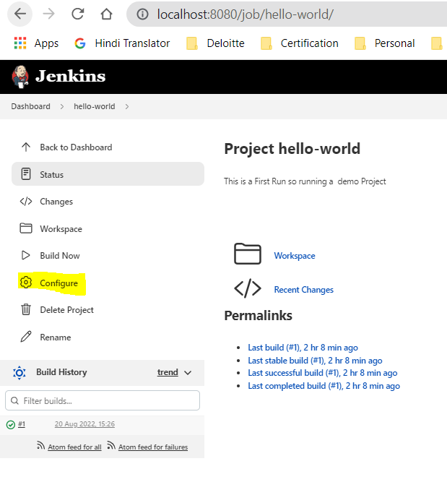

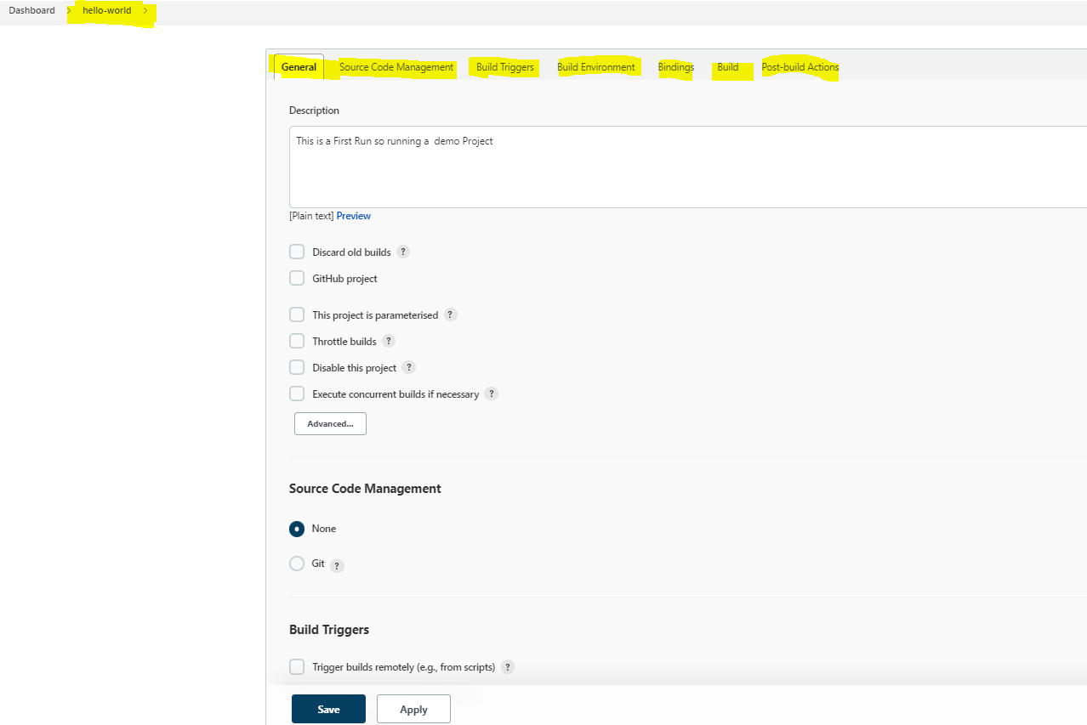

General:This is the first tab in configuration where we can specify the description as well as configure 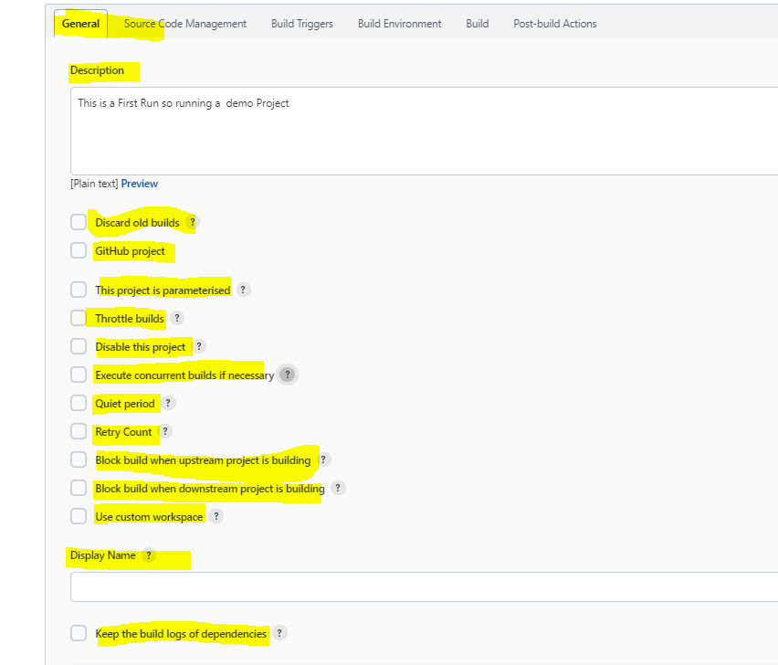

2.Source Code Management:

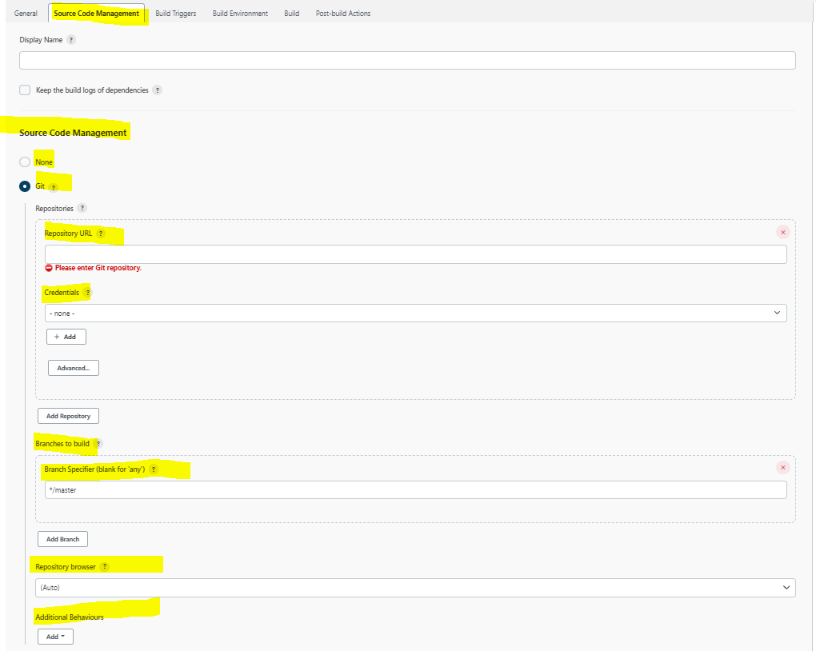

3.Build Triggers:

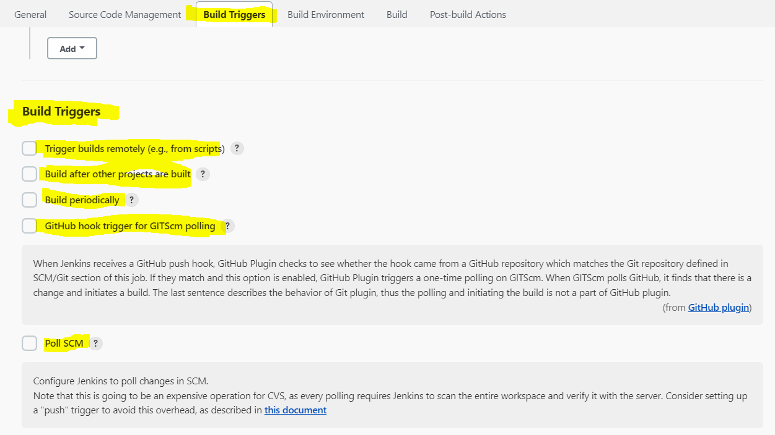

4.Build Environment:

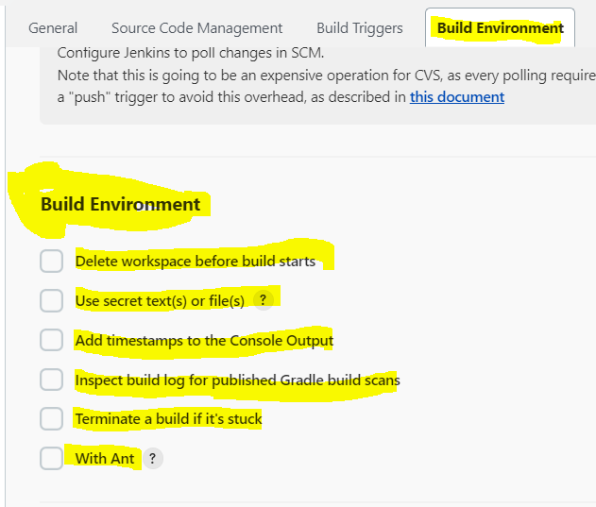

5.Build:

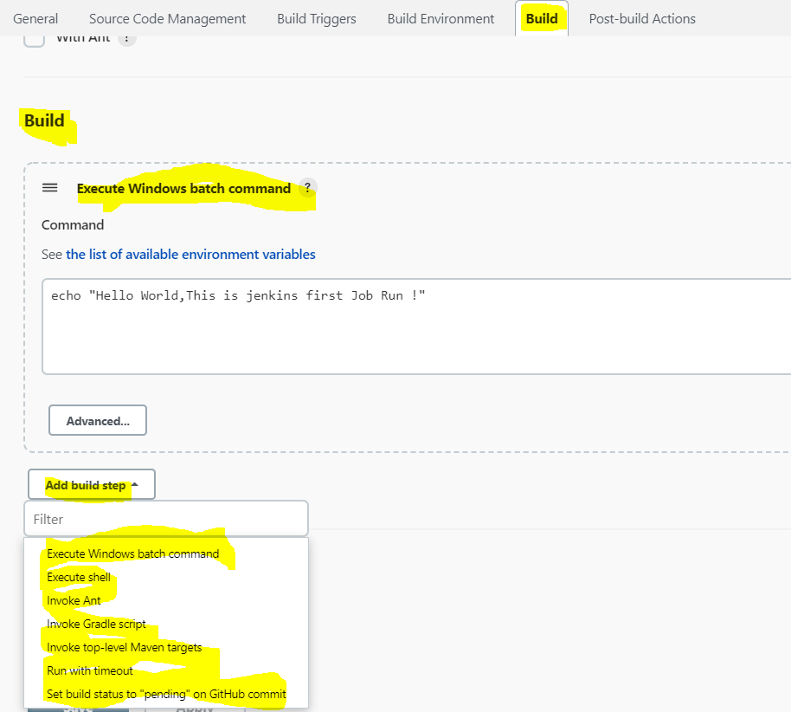

6.Post Build Actions:

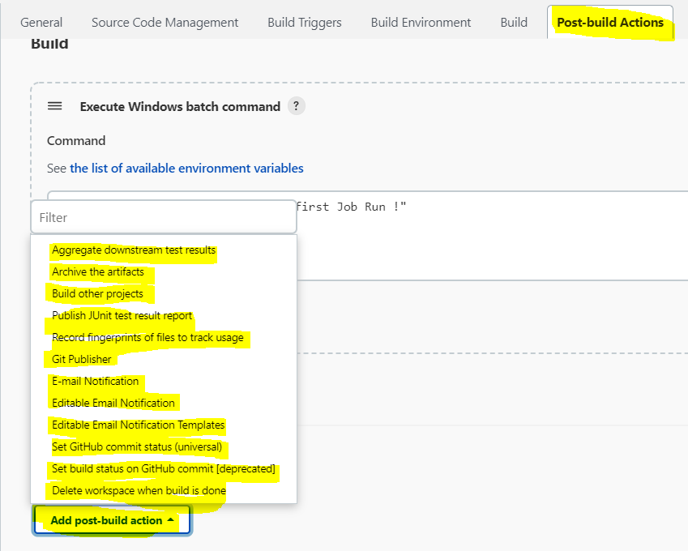

* How to monitor the jobs using Console output and Trends

1)To monitor the job or to see logs we can go to project dashboard->go to specific build no for which you want to see the logs n output->click on that job->select console output there you will see the logs.

2) To monitor the job or to see logs we can go to project dashboard-> on the build history you can click on trend to see the timeline of diff builds.

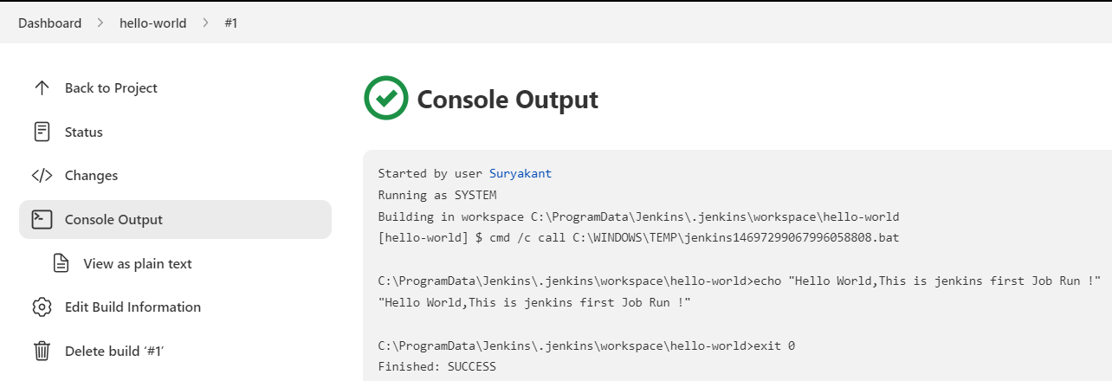

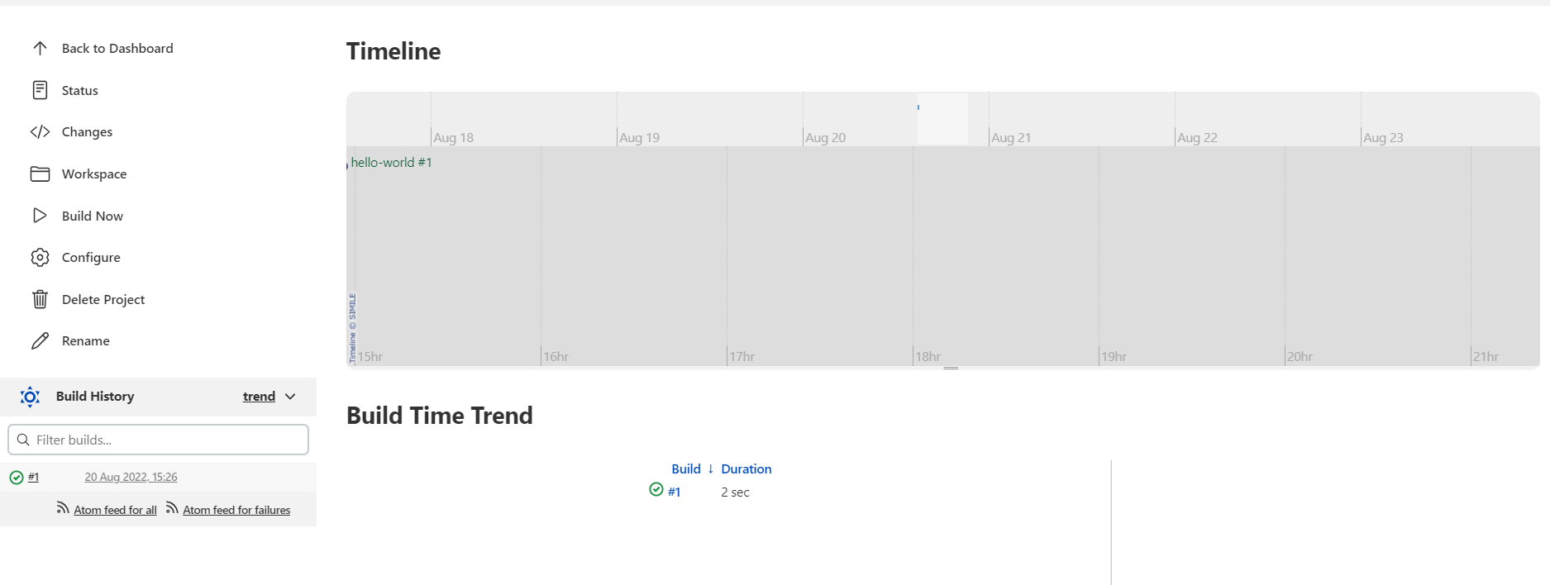

Why would you want to discard old builds? 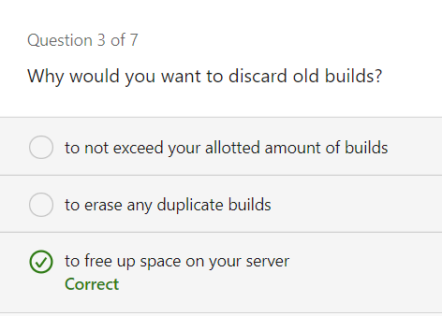

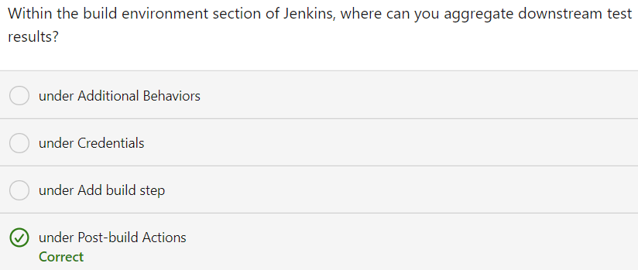

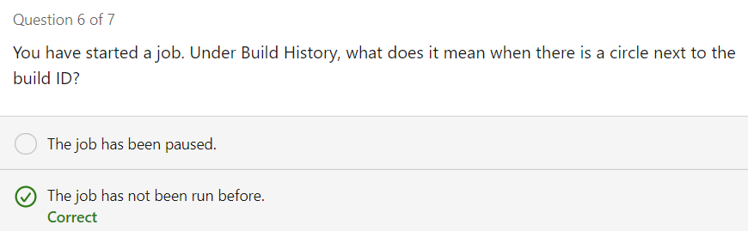

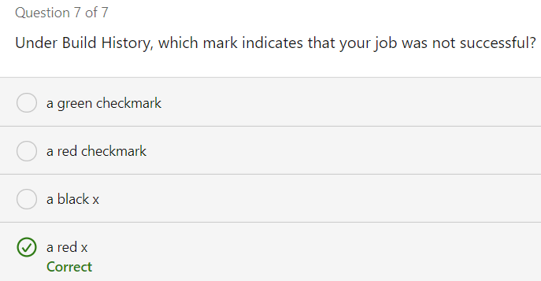

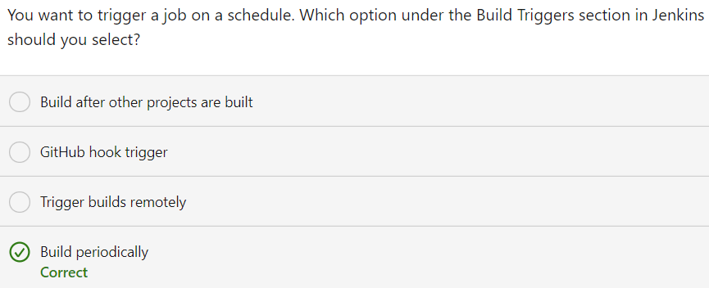

* Using global Tool Configurations for new job:

For the job to configure we need GIT n Maven (Already configured maven 3.8.6 in previous notes) under Manage Jenkins->Global Tool Configurations.

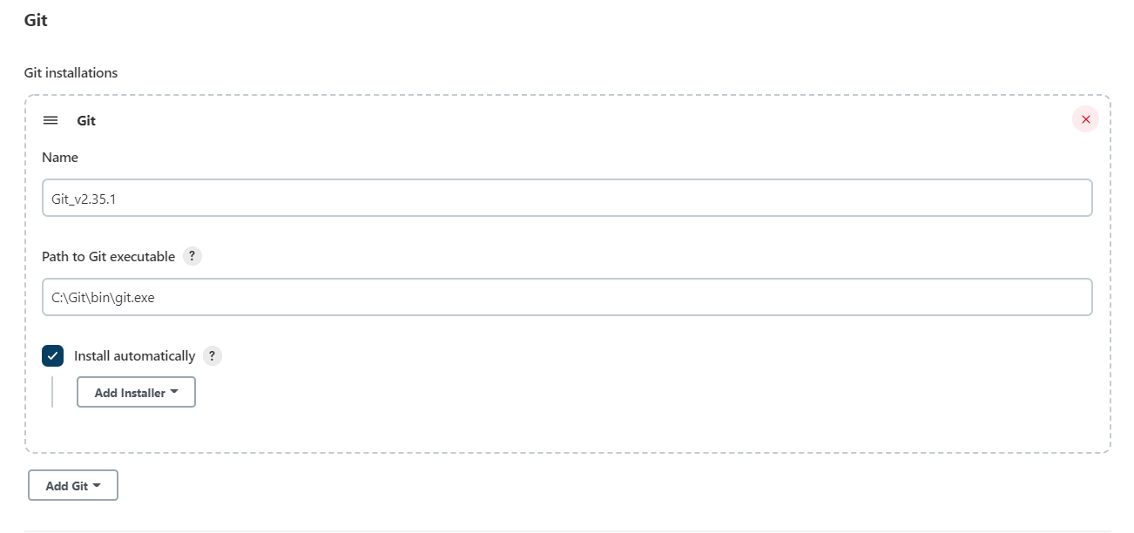

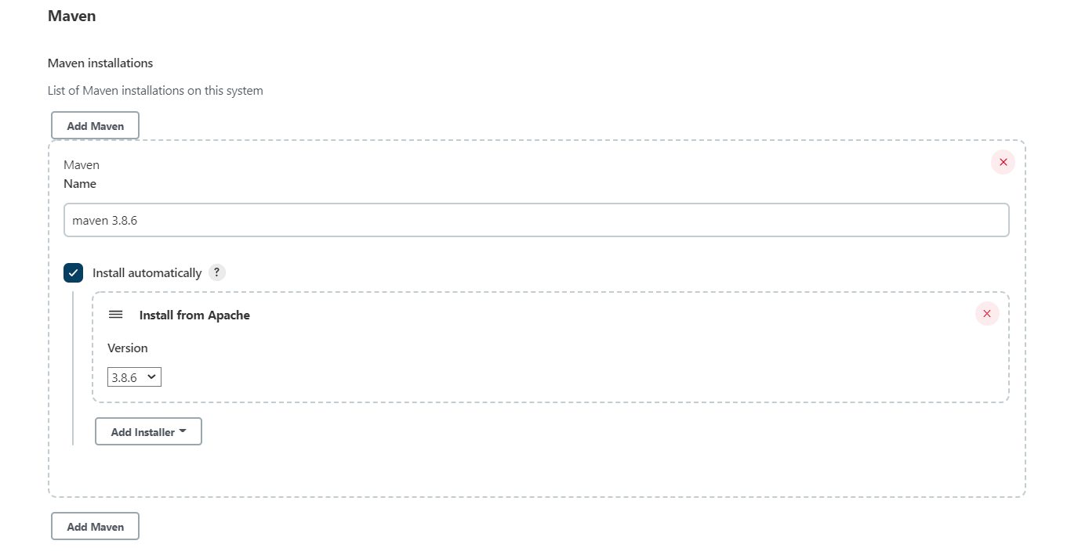

Lets create n configure the new job hello-maven

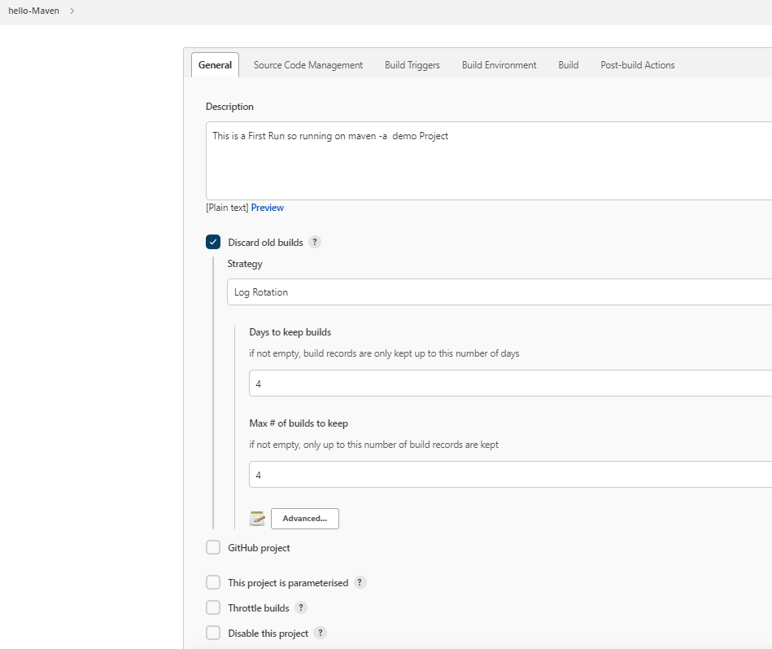

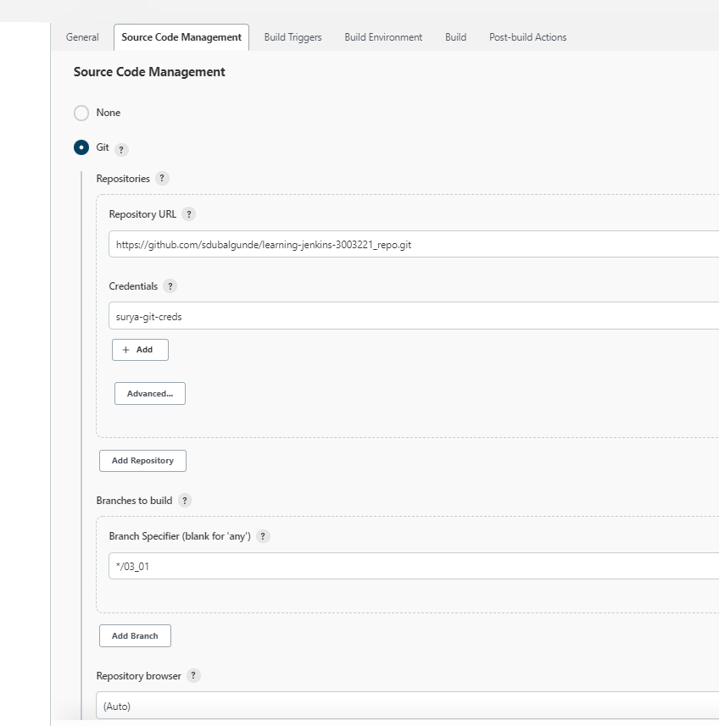

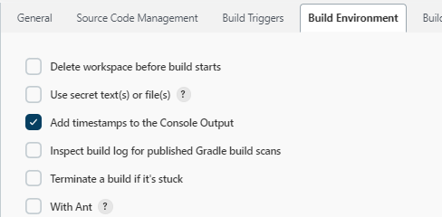

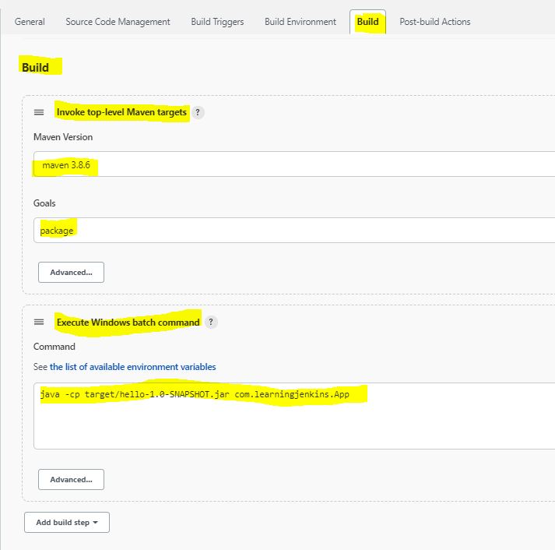

This will result in success result where we will get build records(build results) n build artifacts(.jar file) in the workspace.if we are running the job with maven 3.8.6 n git for a first time then it will take lot of time to get the result as it needs to download that dependencies.from second time it will be much more faster.

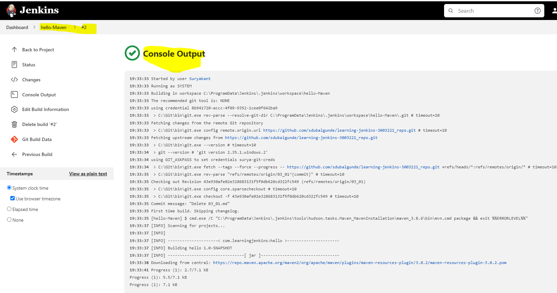

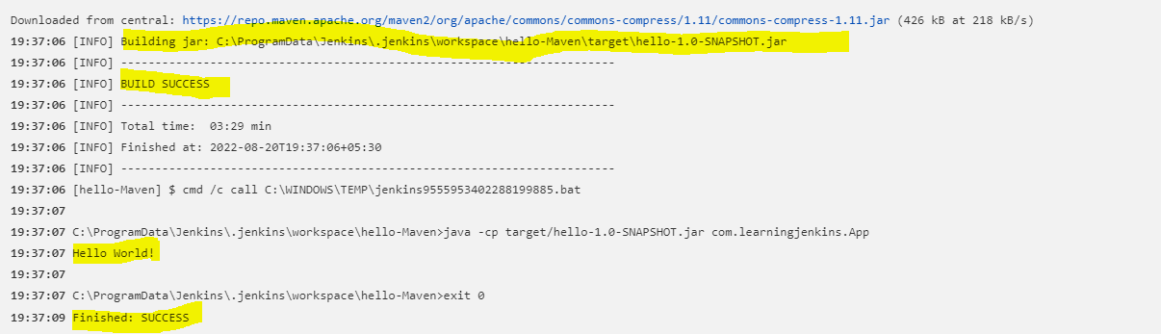

We can check the build records n build artifacts using workspace link on hello-Maven project-Dashboard like below

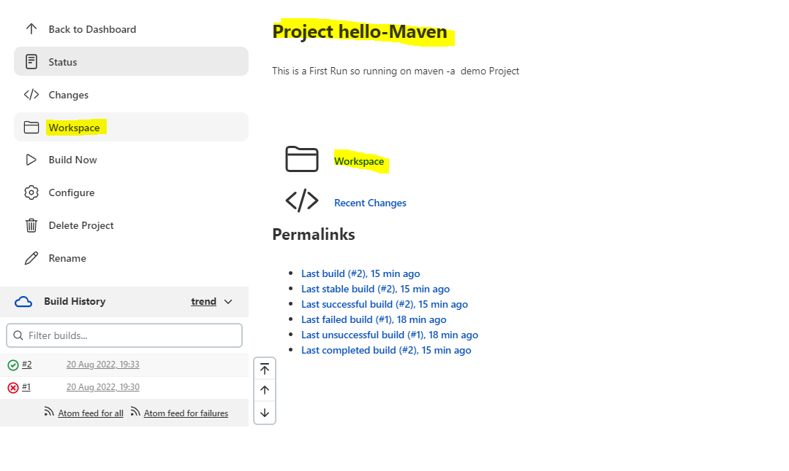

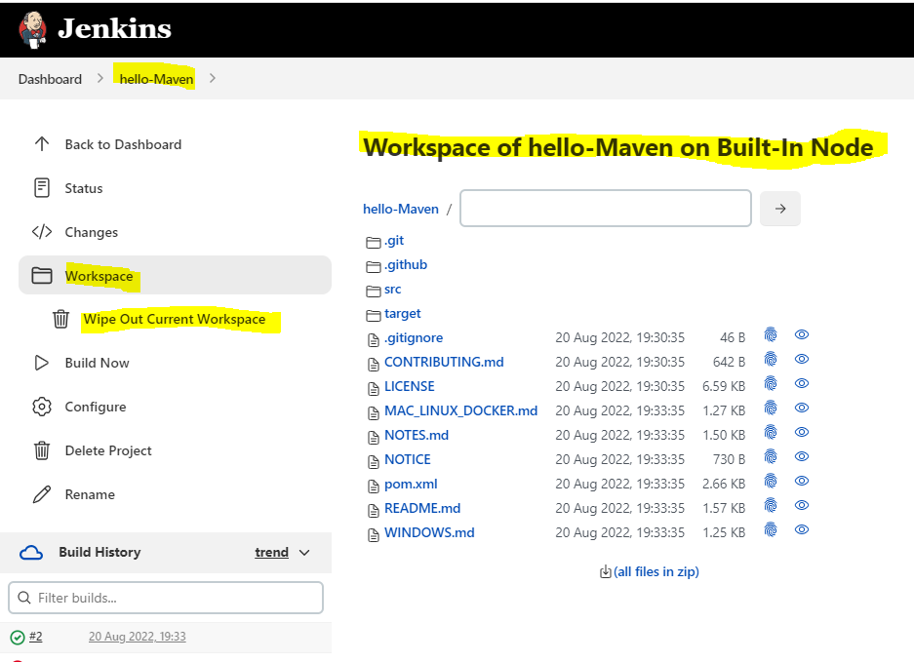 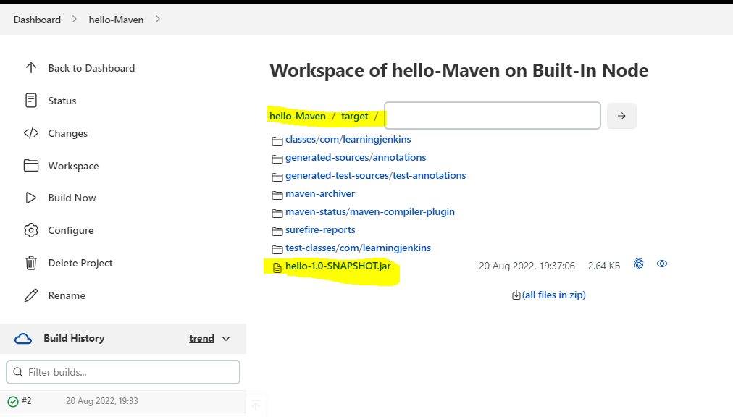

When we select workspace,we also get option to Wipe out Current Workspace ,which is used to delete the workspace . so let say we delete this then don’t worry we can get it back by running the job again.Since in this job we are fetching github repo so we will see github repo filesIts a best practice to delete the workspace becoz all the space taken to store the files will be effecting jenkins performance so it should be deleted. . We can setup the jenkins job to clean up the workspace before or after job ran by using job configuration->Build Environment(before job runs) or Post Build Actions(After job runs).

Lets configure that,

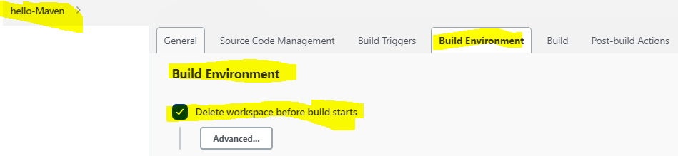

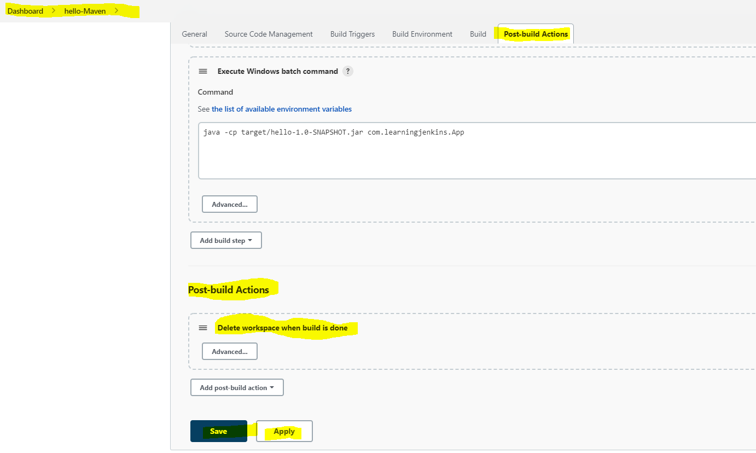

Since we configured both before job run n after the job run the workspace should be deleted so lets check now the job workspace should be deleted after #3 build.

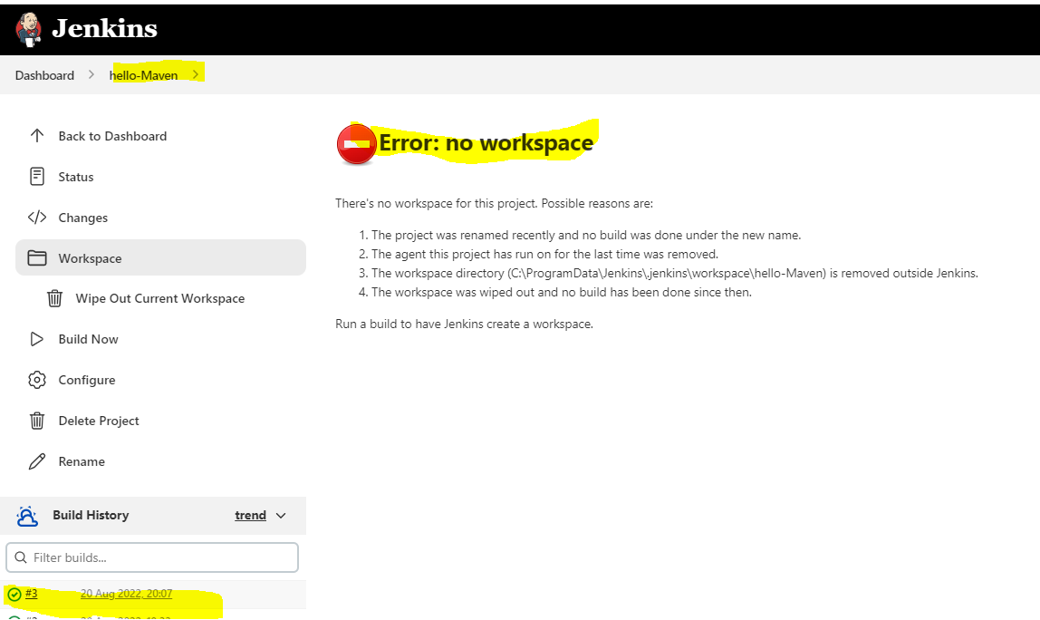

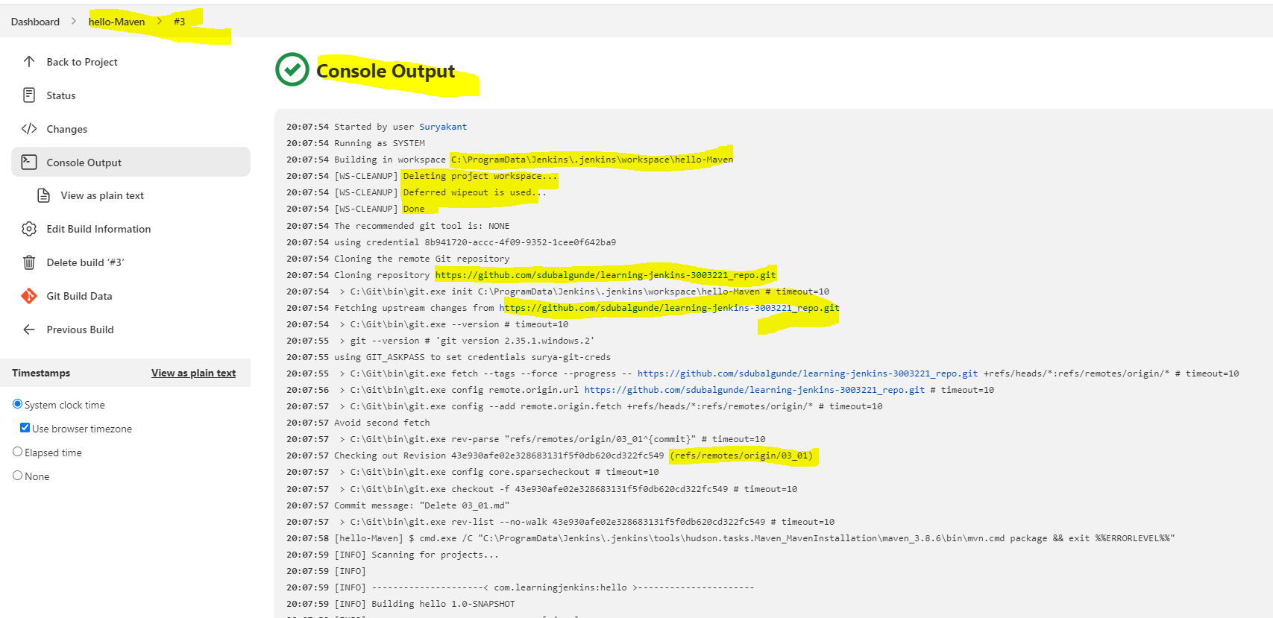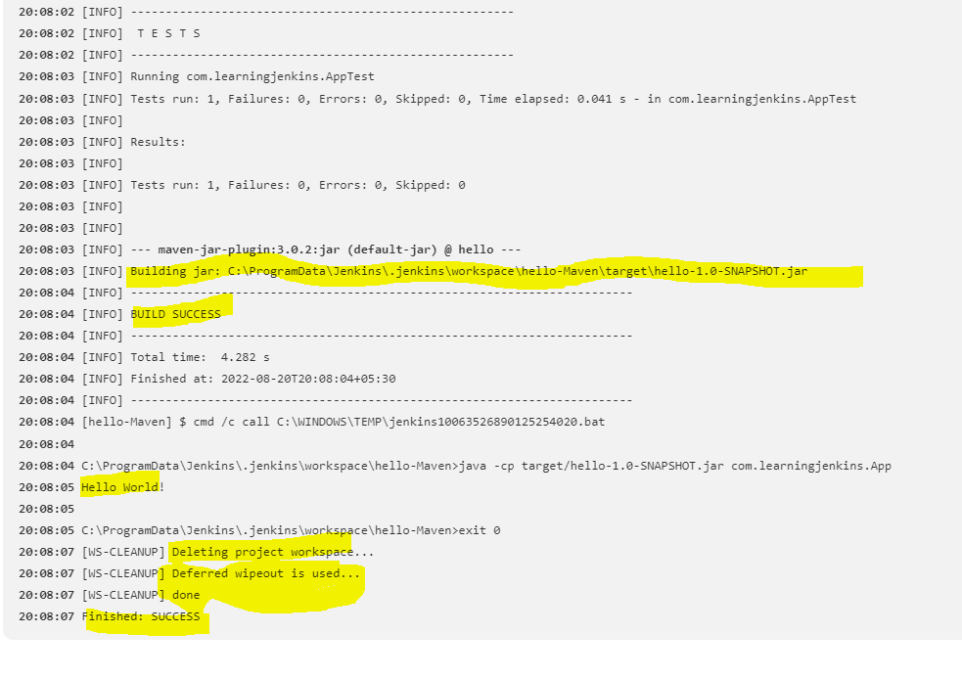

Let’s say we want to archive the jar file after the job ran done then we can configure this in

Project Configuration dashboard-> configure-> Post Build Actions tab

Here we are giving **/filename this is becoz ** allows to search for a file in all the workspace.

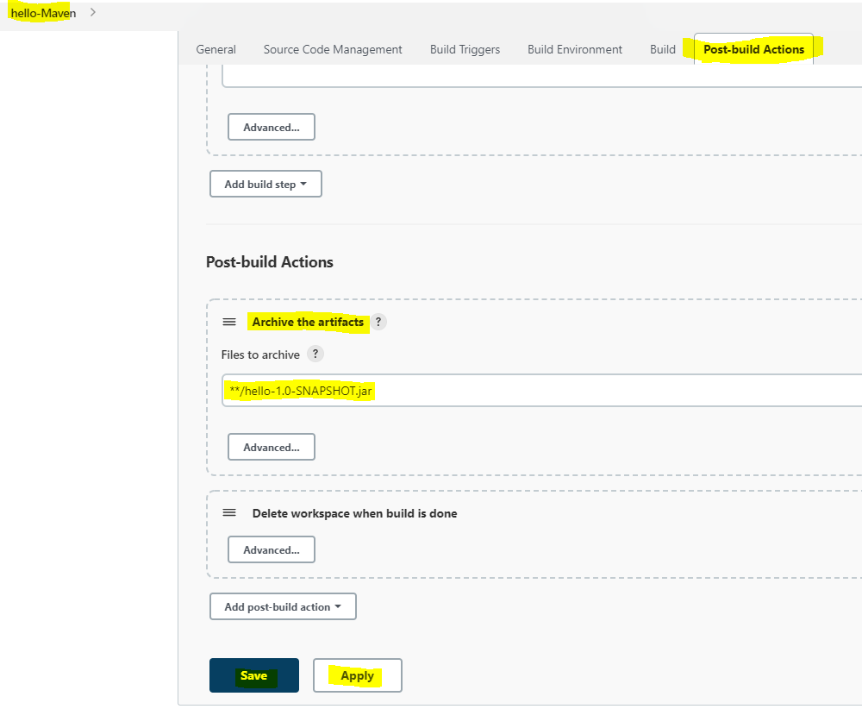

By doing this archive activity, we can able to get the file which we want in project_dashboard directly like below

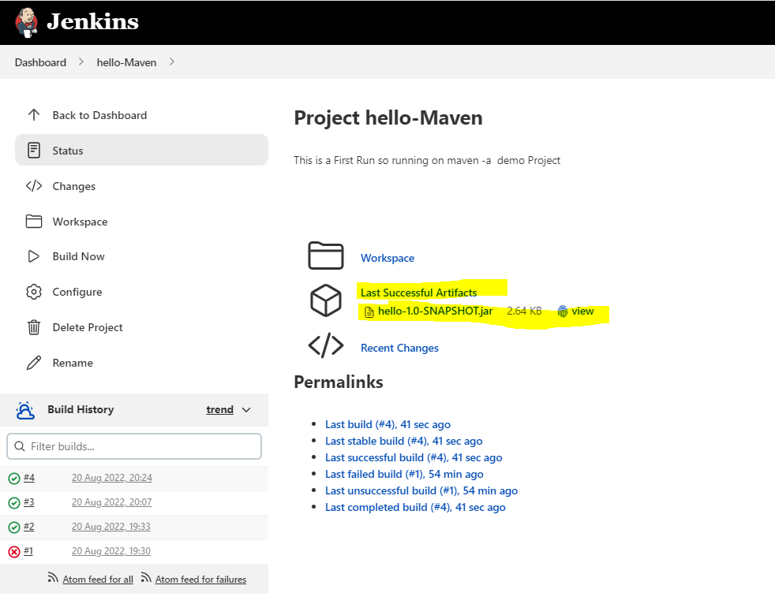

* How Parameters and Environment Variables are used in Jenkins

We can use parameters to apply on diff. situations that parameters can be used as script where the parameters will act as environment variables.Lets configure one new job which is parameterized n uses the parameters like Boolean,choice,string parameters in a new job.

So to configure the job as parameterized we need to select project_dashboard->configure->General tab->select the project is parameterised ->click add parameter->from dropdown create Boolean,string,choice parameters.

The declared parameters we can use as environment variables in our configuration-> build->add build steps->execute Windows batch command like below

%Variable-Name%

For eg:-

@echo API-Version= %API_VERSION%

Note that the name of the variable is not case sensitive in windows but it is case sensitive for other OS. For other os we can use $ Variable-Name$

Let say we kept job name as Parameterized-Job n configured the job as below: 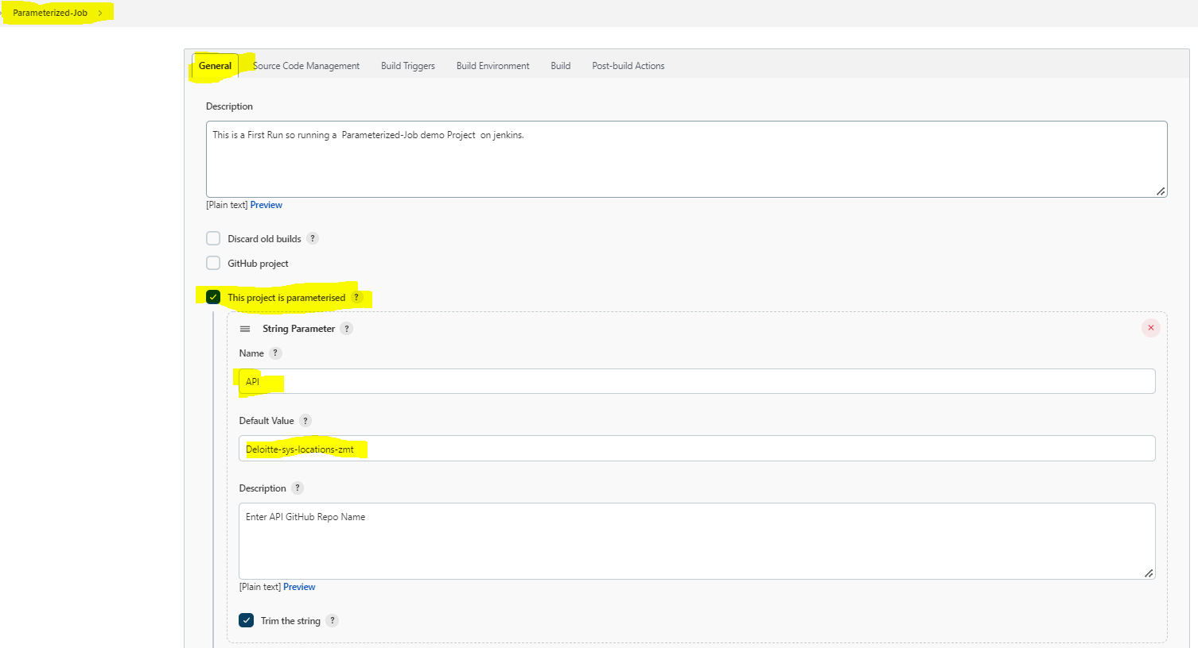

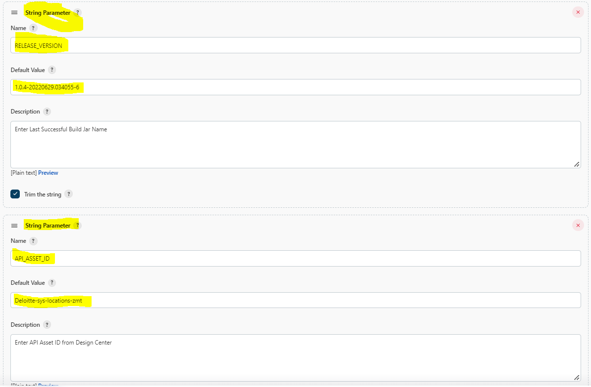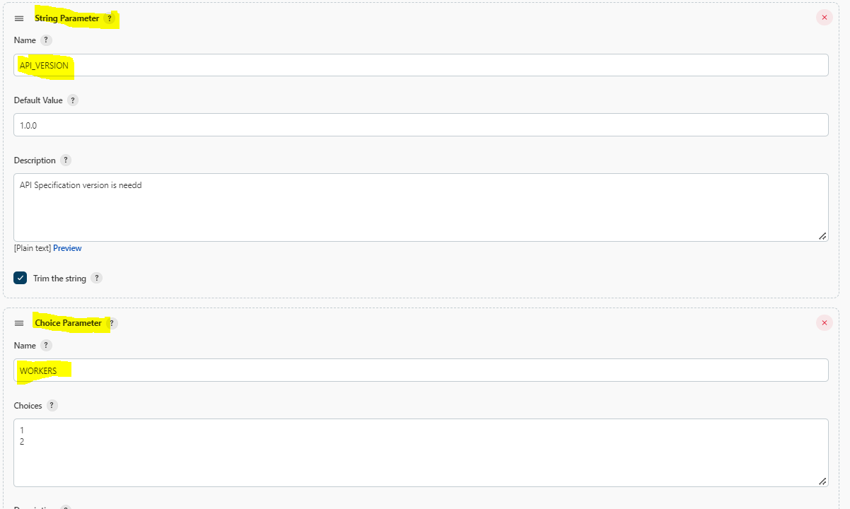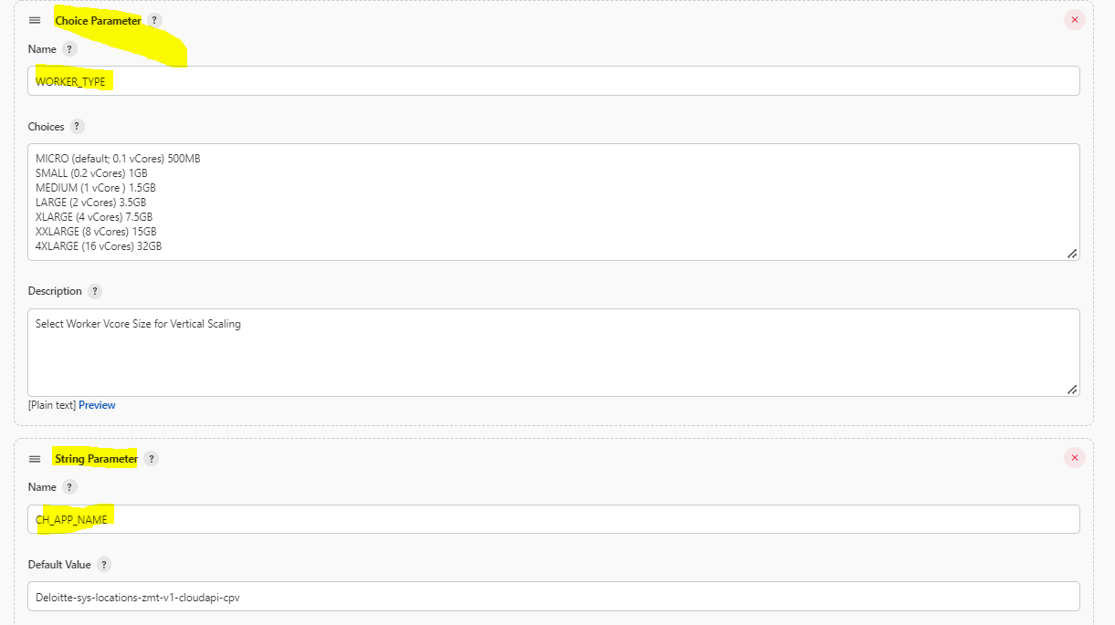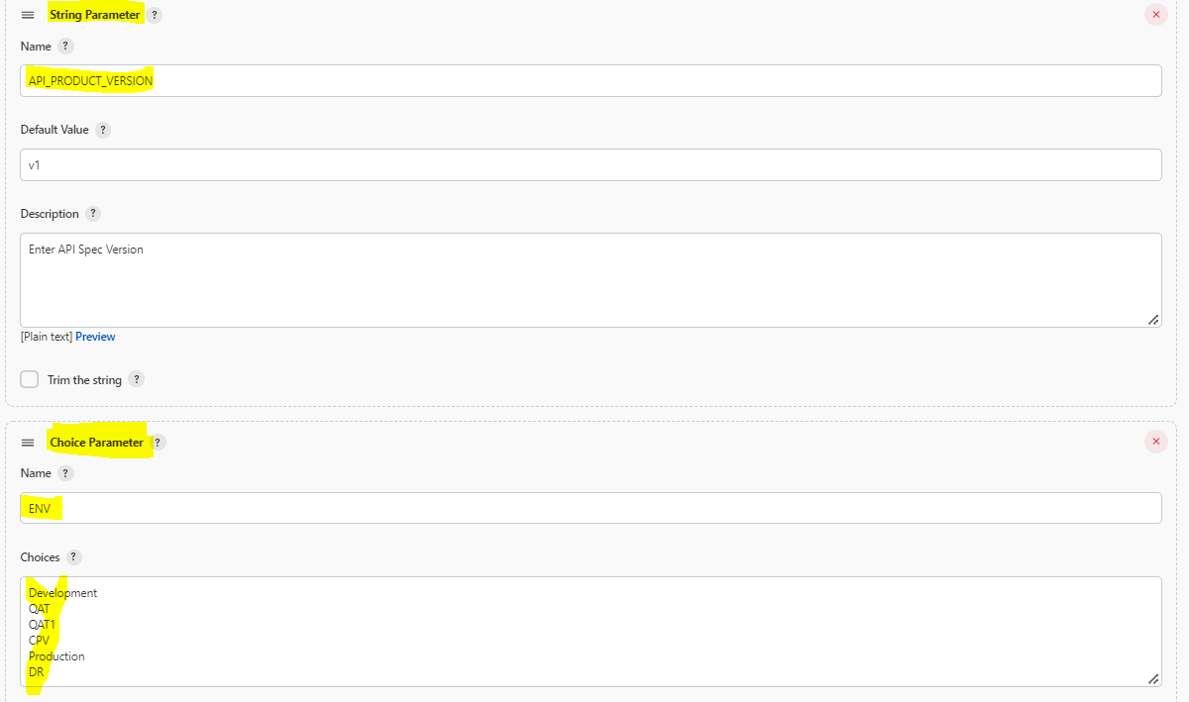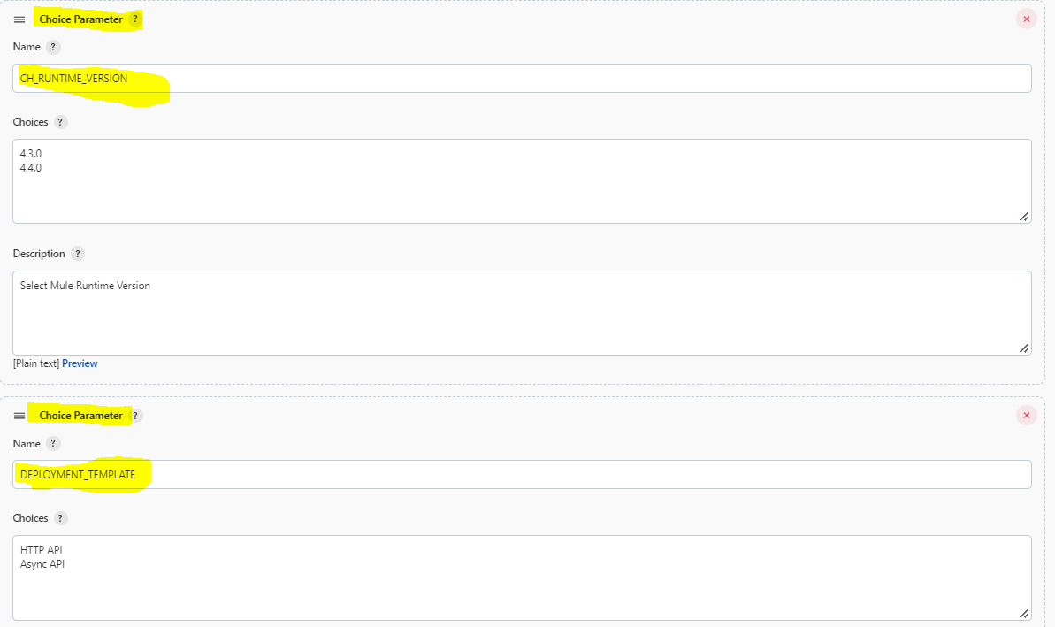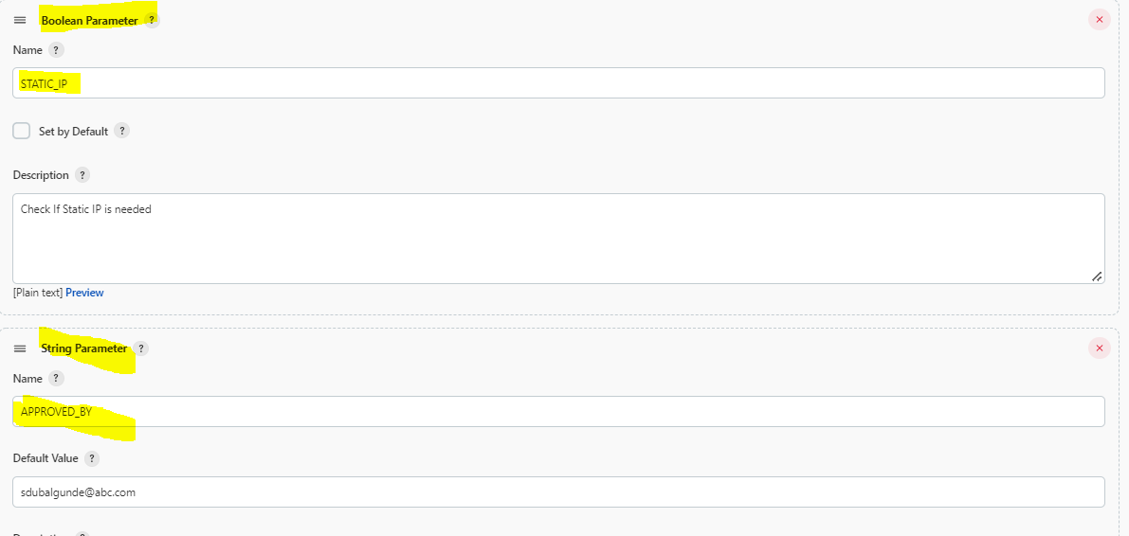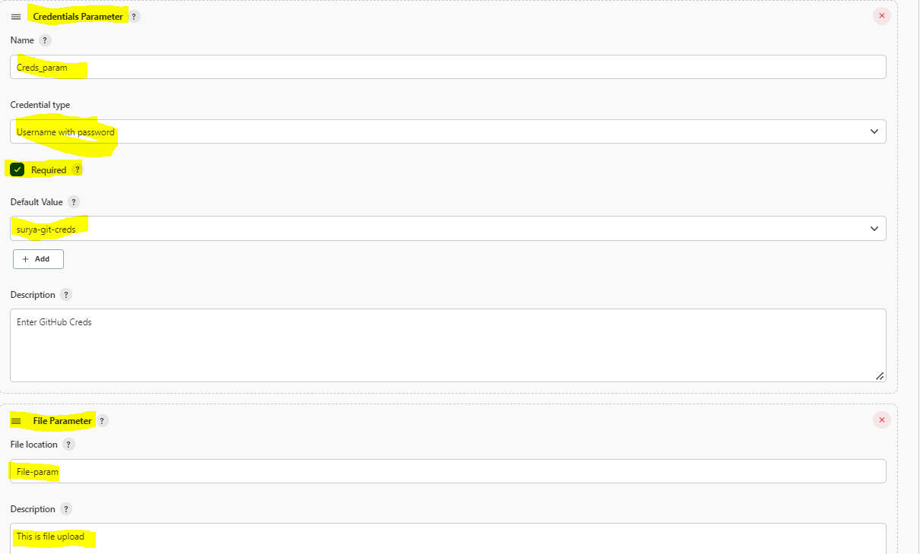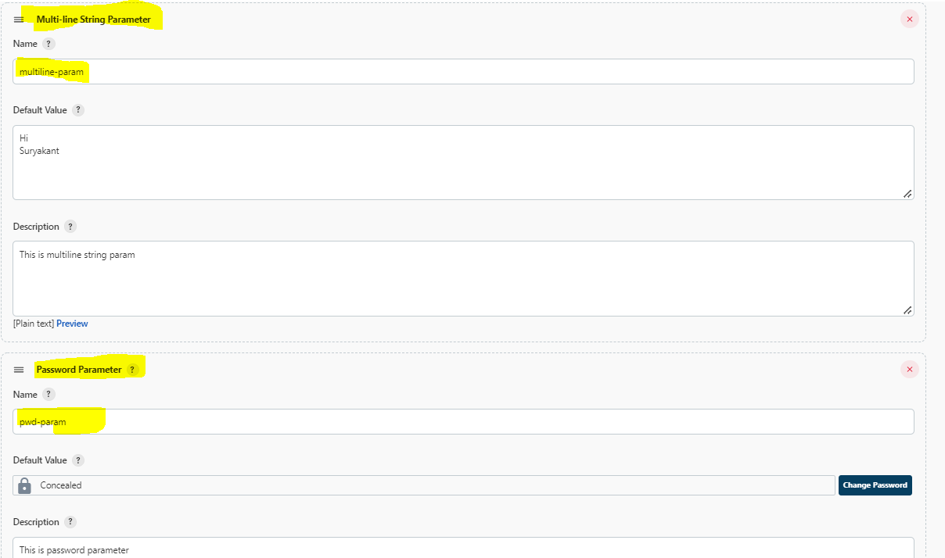

Result of this is ,

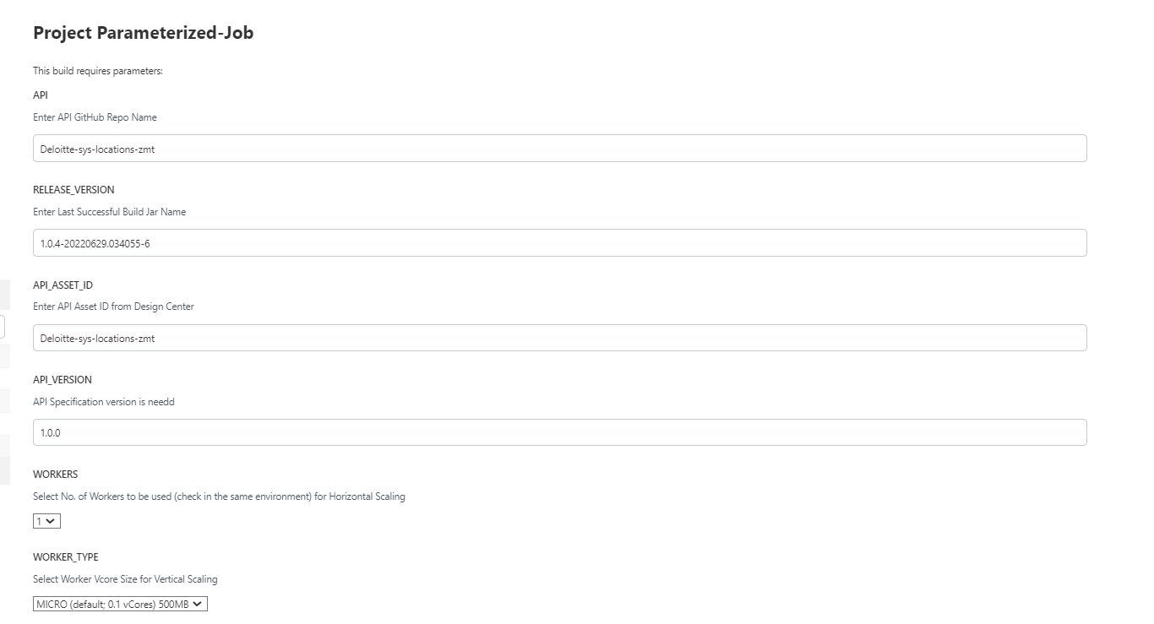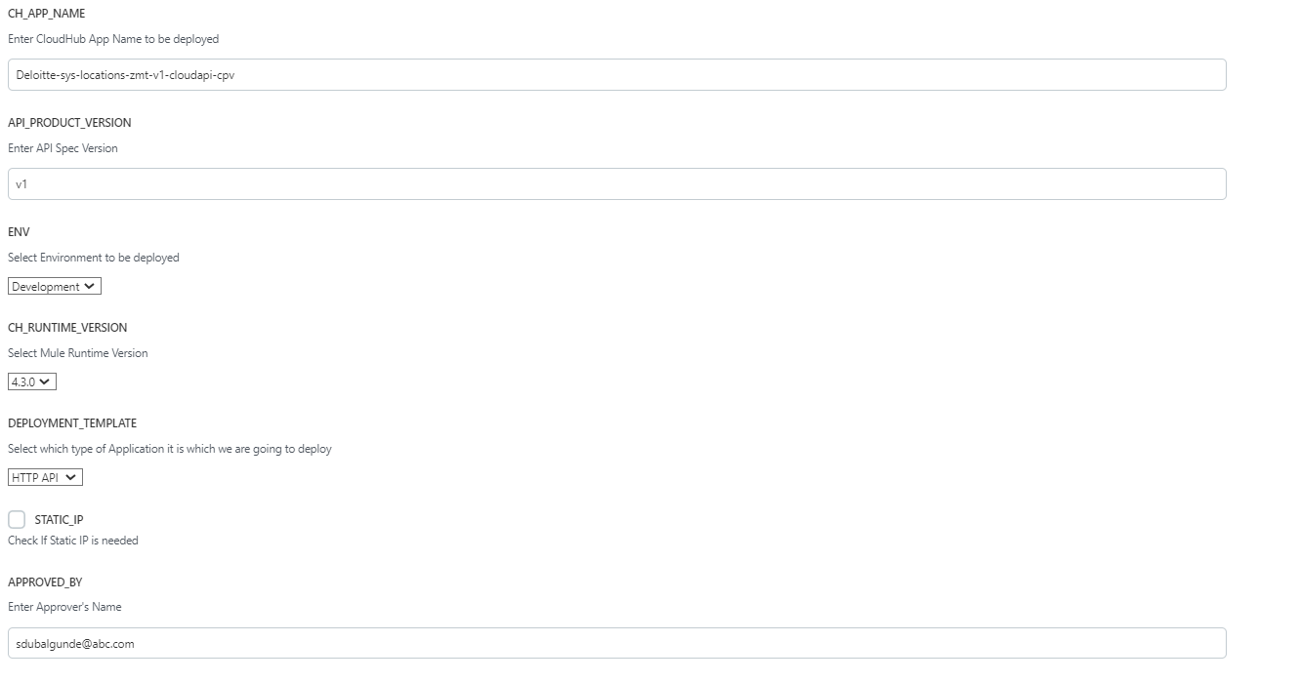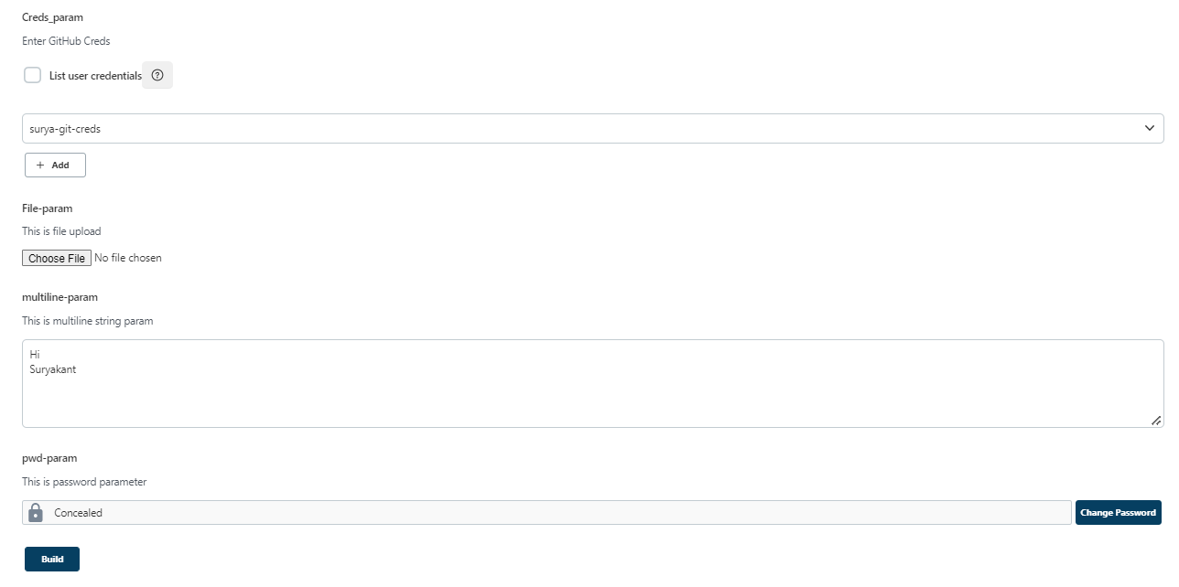

Using Parameters as Environment variables in Build tab

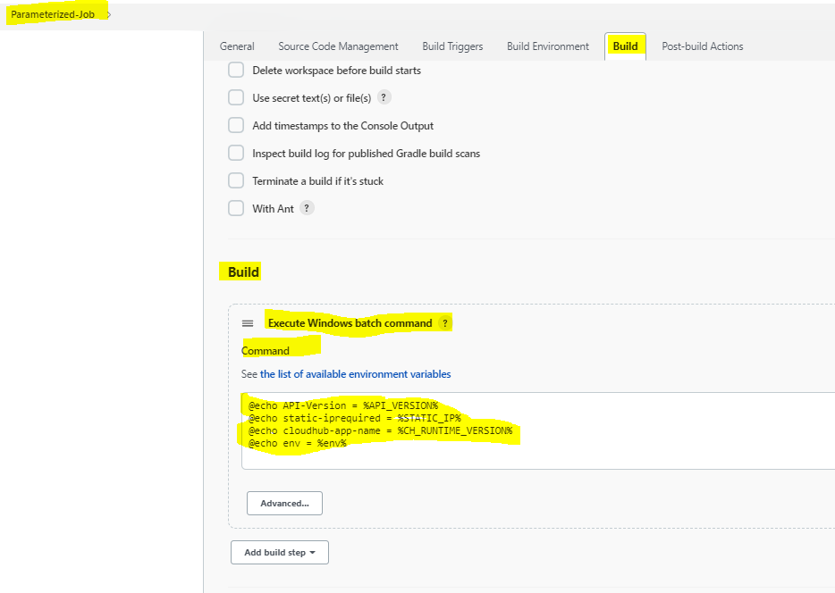

Once done with configuring job the click save n then you will see project-dashboard will have build with parameters button instead of build Now button. When you click on build with parameters you will see all parameters in middle panel like below

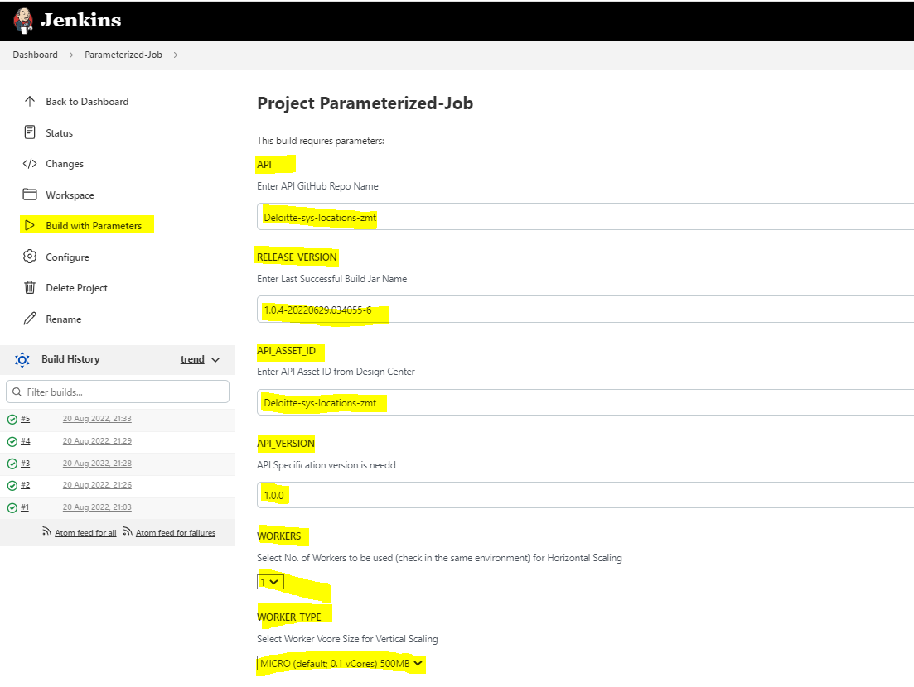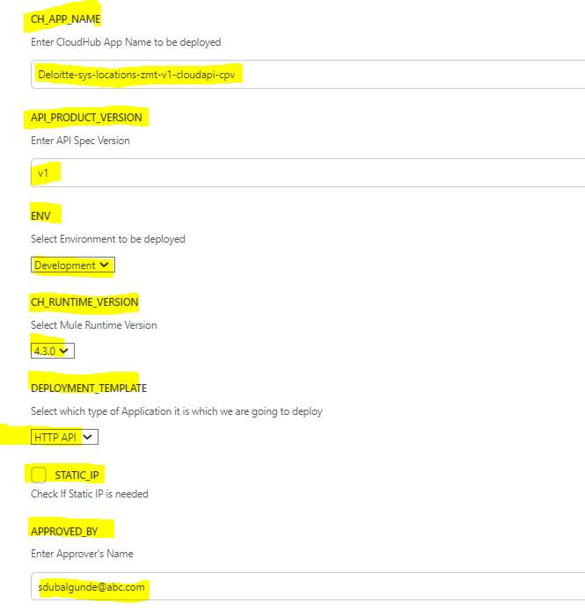

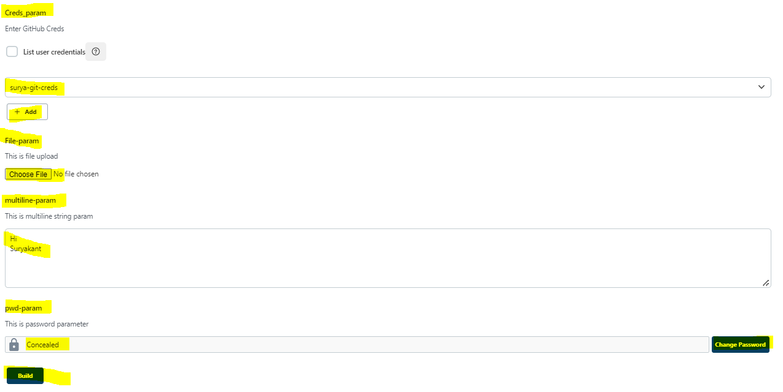

When you fill all parameters n click on Build option->will trigger the job n give the output as below

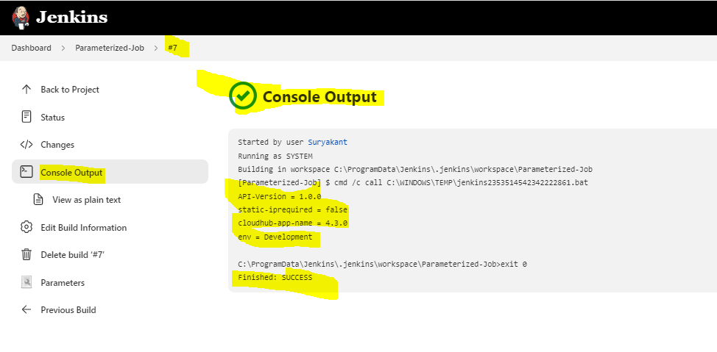

* How to schedule a job?

To schedule a job to run in particular schedule we can use project_dashboard->configure->Build Triggers->Build Periodically n then u can use below cron format to schedule a job.

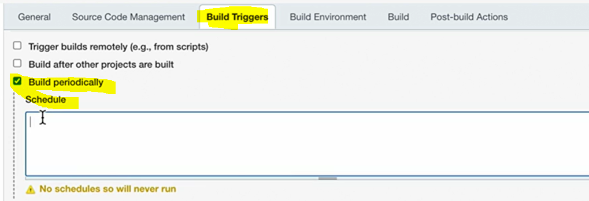

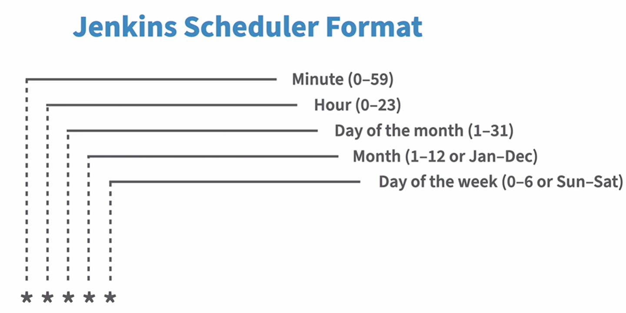

If we configure

1. * * * * * will run at every minute let say now last run was 4:11 then next will be 4:12

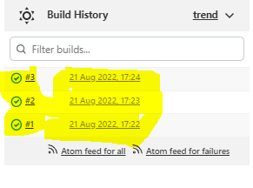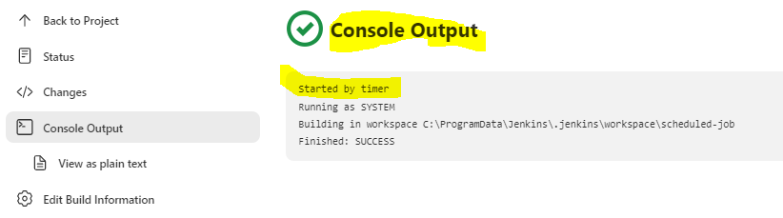

1. 11 * * * * will run @ every hour @11th minute of every hour let say now last run was 4:11 then next will be 5:11
2. 11 3 * * * will run at every day @3:11 minute let say now last run was @3.11 of 21 aug 2022 so next run will be @ 3:11 of 22 aug 2022
3. 11 3 5 * * will run @ every 5th of each month @3:11 let say now last run was 5th Aug 2022 @3.11 then next run will be on 5th of Sep 2022 @3.11
4. 11 3 5 7 * will run @ every 7th of each day of the week(0-6,sun-sat) i.e July month on 5th July @3:11 let say now last run was 5th july 2022 @3.11 then next run will be on 5th of July 2023 @3.11
5. 11 3 5 7 6 will run @ every Saturday of July month when there is a 5th day of July @3:11 so it is very rare condition that 5th of July will be Saturday @3:11
6. 0 7 11-17 * 2 will run @every Tuesday of every month when the day is between 11-12 @7:0 am i.e **first Tuesday after the second Saturday of every month @ 7AM**

Why 11-17 is As per logic, for every month the second saturday can lie between 8-14, and hence tuesday after that can lie between 11-17 so we want ot run the job after 2nd Saturday ke bad aanewala Tuesday

* How to organize jobs in Jenkins?What are views in Jenkins? What are folders?

To organize jobs in Jenkins,we can use views n folders.

Views are like filters where we give the filter condition n based on that the jobs will get stored in view or we can manually select each job.

Folder is an organizing way where we create folders n move the each job manually in the respective folder

How to create view?

Go to Jenkins_dashboard(Main page) by default in main page we can see jos that are created so to create a view we can either click on new view or click on + button in middle panel where we can see all jobs listed like below:

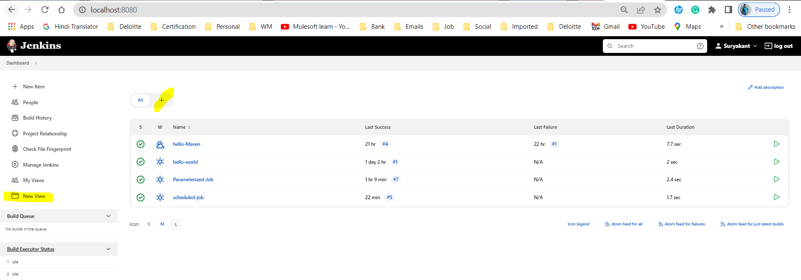

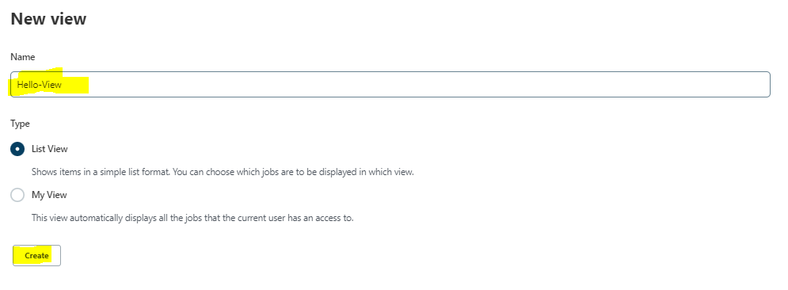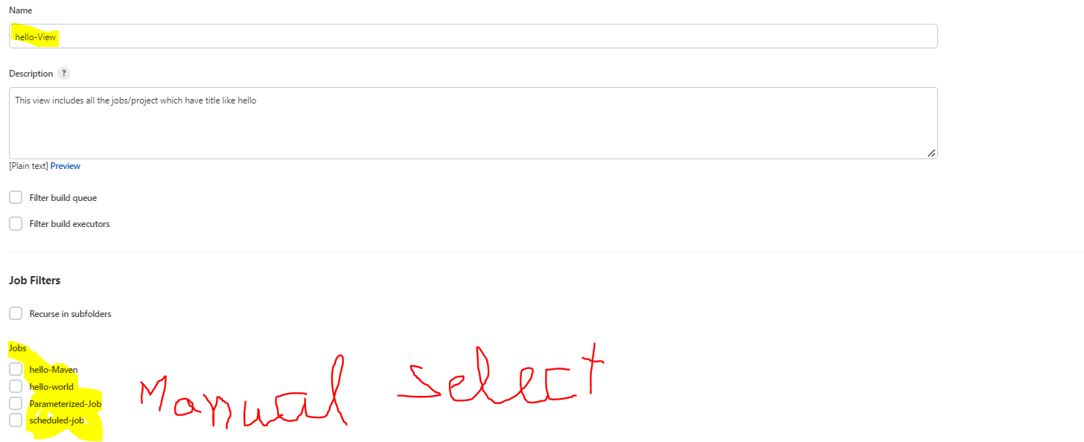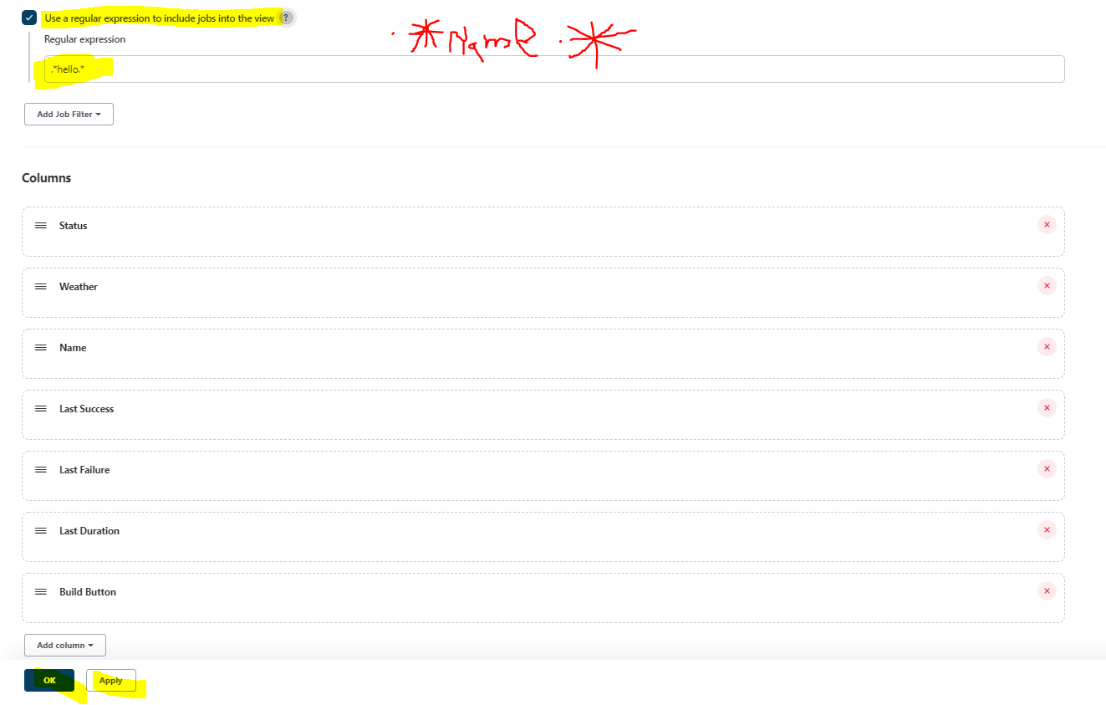

Result of the above img is

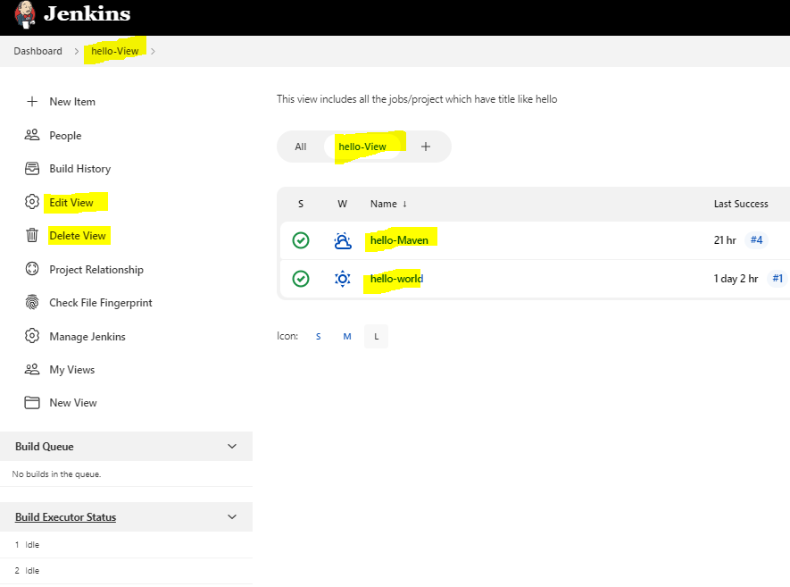

Note that Regular expression field is case sensitive so if we have jobs with name which are involves Hello n in regular expression we are writing .*hello.* then no files will be shown in hello-view view

Once configured u can edit as well as delete the view.Deleting view wont delete the jobs in Jenkins.

How to Create folder:

Go to main page(Jenkins_Dashboard)->New Item->Give Name->Select Folder

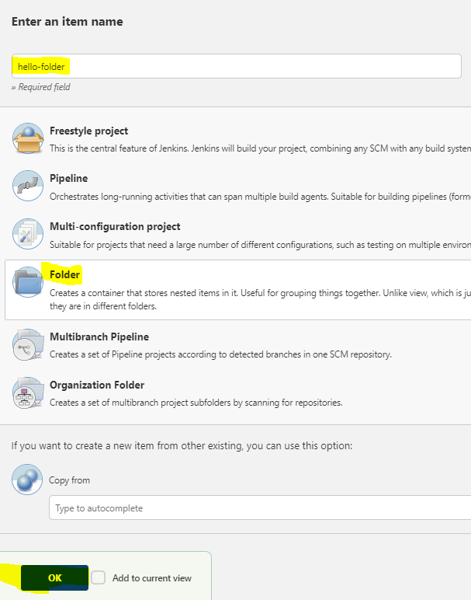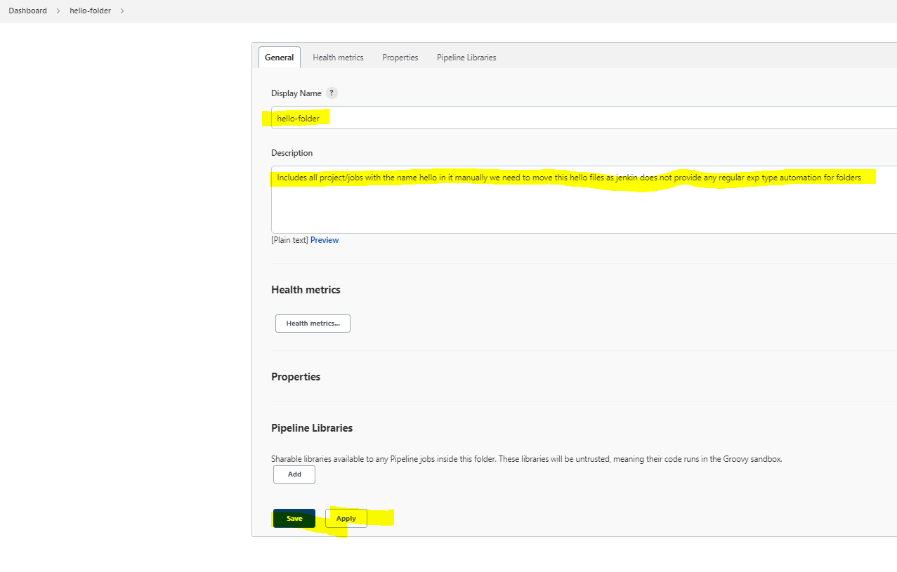

To manually move hello jobs inside the hello folder,

Go to main page->in middle panel click All there u will see newly created folder as well as jobs also->hover on job name which you want to move to hello folder there beside of job name u will see a dropdown click on that n then u will see option to move

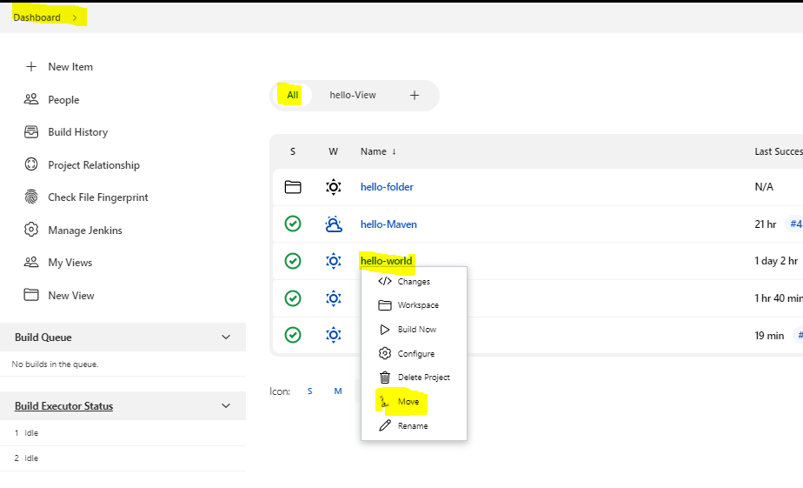

From dropdown select Jenkins>>hello-folder to move the job.

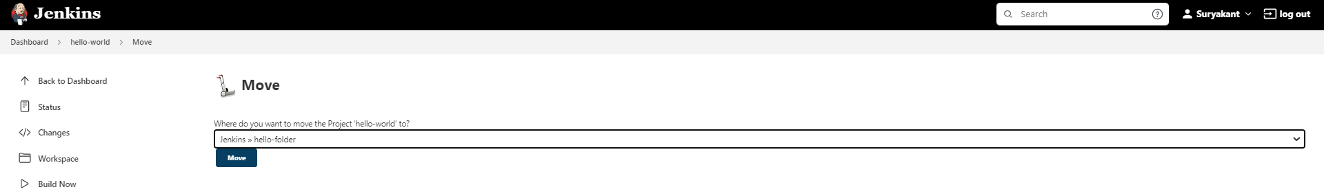

Folders that we created will be visible on main page in middle panel where All is selected n view is visible in main page in middle panel where we will see separate tab for each view we created. 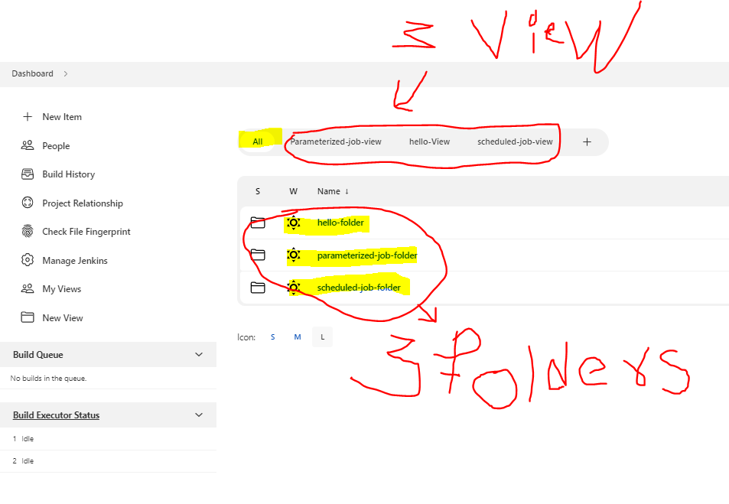

Deletion of View/Folder:

Deletion of view in which we have some jobs wont delete the jobs in Jenkins server but deletion of folders in which we have some jobs will delete the jobs from Jenkins server.

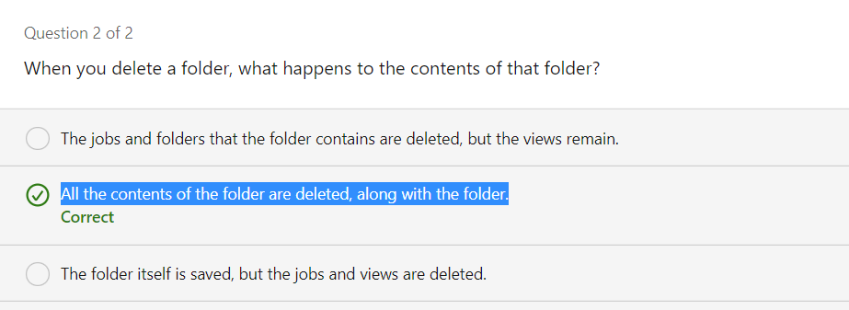

* Pipeline style Project:

Pipeline is a code stored in a file named jenkinsfile this Jenkinsfile can be stored in Repo also.Pipeline contains stages n steps.stages are sections of the pipeline. And each stage can have minimum 1 steps that needs to be defined.Steps are the actions that taken in each stage.

Jenkinsfile is known as ‘pipeline as a code’.there are two types of syntax that we can use to write in pipeline

1.Declarartive

2 Scripted

Both use Groovy but have diff structure. We can have jenkinsfile script created in pipeline script or from any git repo

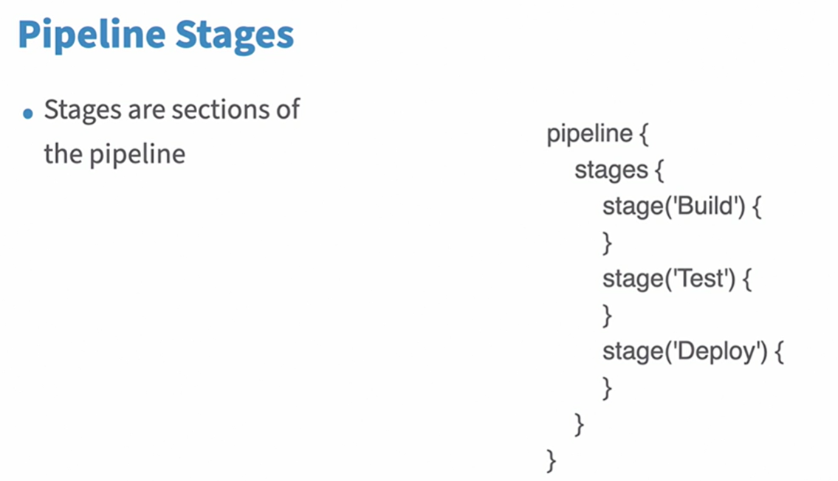

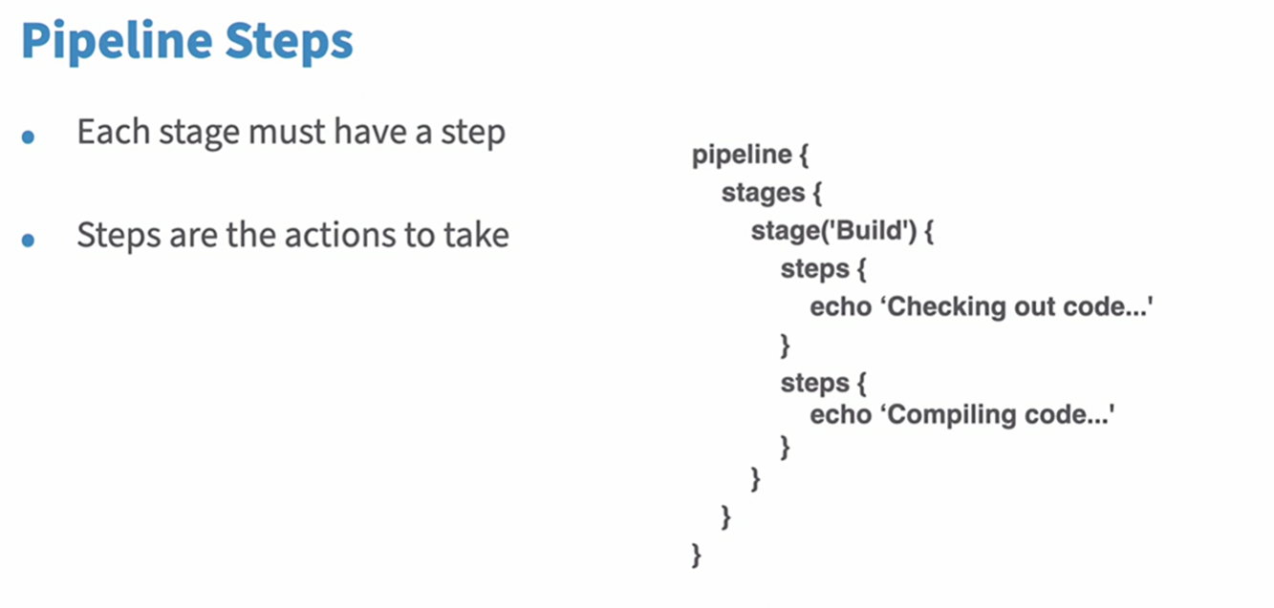

Lets create a pipleline project called pipeline-job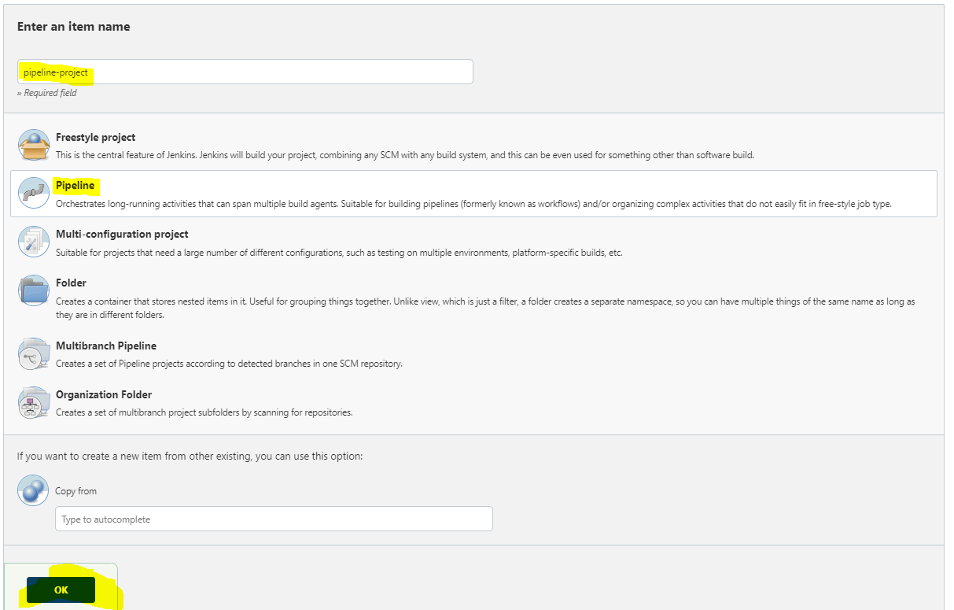 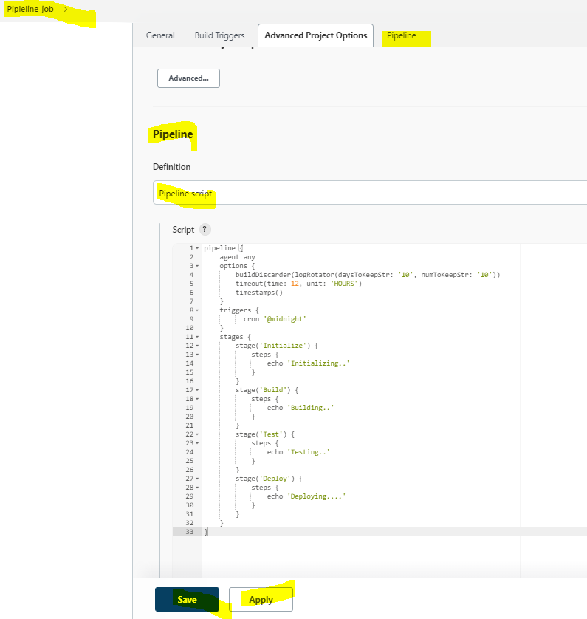

After running the Build Now job,we get following visual output. N it’s very easy to navigate to the output if any steps failed go to that step n click on the step to see the log.



